UNITED STATES
SECURITIES AND EXCHANGE COMMISSION

Washington, D.C. 20549

FORM 8-K

CURRENT REPORT

Pursuant to Section 13 or 15(d) of The Securities Exchange Act of 1934

Date of Report (Date of earliest event reported): September 8, 2026

INTEGRA LIFESCIENCES HOLDINGS CORPORATION
(Exact Name of Registrant as Specified in its Charter)

Delaware |  |  | 0-26224 |  |  | 51-0317849
(State or Other Jurisdiction of Incorporation or Organization) |  |  | (Commission File Number) |  |  | (IRS Employer Identification No.)

1100 Campus Road
Princeton, NJ 08540
(Address of principal executive offices) (Zip Code)
Registrant's telephone number, including area code: (609) 275-0500

Not Applicable
(Former name or former address, if changed since last report)

Check the appropriate box below if the Form 8-K filing is intended to simultaneously satisfy the filing obligation of the registrant under any of the following provisions (see General Instruction A.2. below):

☐ Written communications pursuant to Rule 425 under the Securities Act (17 CFR 230.425).

☐ Soliciting material pursuant to Rule 14a-12 under the Exchange Act (17 CFR 240.14a-12).

☐ Pre-commencement communications pursuant to Rule 14d-2(b) under the Exchange Act (17 CFR 240.14d-2(b)).

☐ Pre-commencement communications pursuant to Rule 13e-4(c) under the Exchange Act (17 CFR 240.13e-4(c)).

Securities Registered Pursuant to Section12(b) of the Act:
Title of Each Class |  |  | Trading Symbol |  |  | Name of Exchange on Which Registered
Common Stock, Par Value $.01 Per Share |  |  | IART |  |  | Nasdaq Global Select Market

Indicate by check mark whether the registrant is an emerging growth company as defined in Rule 405 of the Securities Act of 1933 (§230.405 of this chapter) or Rule 12b-2 of the Securities Exchange Act of 1934 (§240.12b-2 of this chapter).

Emerging growth company ☐
If an emerging growth company, indicate by check mark if the registrant has elected not to use the extended transition period for complying with any new or revised financial accounting standards provided pursuant to Section 13(a) of the Exchange Act. ☐

Item 7.01 Regulation FD Disclosure.

Integra LifeSciences Holdings Corporation (the “Company”) hereby furnishes the updated investor presentation attached as Exhibit 99.1 to this Current Report on Form 8-K, which the Company may use, from time to time, in presentations to existing or prospective lenders in connection with the Company’s previously-disclosed plans to refinance its outstanding senior credit facility in 2026.

The information in this Item 7.01, including Exhibit 99.1, shall not be deemed “filed” for purposes of Section 18 of the Securities Exchange Act of 1934, as amended (the “Exchange Act”) or otherwise subject to the liability of such section, nor shall it be deemed incorporated by reference in any filing of the Company under the Securities Act of 1933, as amended, or the Exchange Act, regardless of any general incorporation language in such filing, unless expressly incorporated by specific reference in such filing.

Item 9.01 Financial Statements and Exhibits.

(d) Exhibits

99.1 Investor Presentation, dated September 8, 2026

104 Cover Page Interactive Data File (embedded within the inline XRBL document)

SIGNATURES

Pursuant to the requirements of the Securities Exchange Act of 1934, the registrant has duly caused this report to be signed on its behalf by the undersigned hereunto duly authorized.

 |  |  | INTEGRA LIFESCIENCES HOLDINGS CORPORATION
Date: September 8, 2026 |  |  | By: |  |  | /s/ Lea Knight
 |  |  |  |  |  | Lea Knight
 |  |  | Title: |  |  | Executive Vice President and Chief Financial Officer



COLOR PALETTE Text 31 73 125 Title bar/Bullets 31 59 83 ACCENTS 1 31 59 83 140 179 212 2 30 105 142 143 202 231 3 47 177 52 165 231 167 4 54 132 156 166 210 224 5 140 181 202 209 225 234 6 191 191 191 229 229 229 Hyperlink 31 59 83 140 179 212 Followed Hyperlink 30 105 142 143 202 231 Lines 31 73 125 Highlights 31 59 83 TABLE Investor Presentat ion September 2026 These materials are not to be printed, downloaded or distributed. These materials are only available to QIBs and non-US persons. This presentation includes information that (i) is publicly available (or could be derived from publicly available information) and (ii) does not constitute material nonpublic information with respect to the company, its subsidiaries or its or their respective securities.

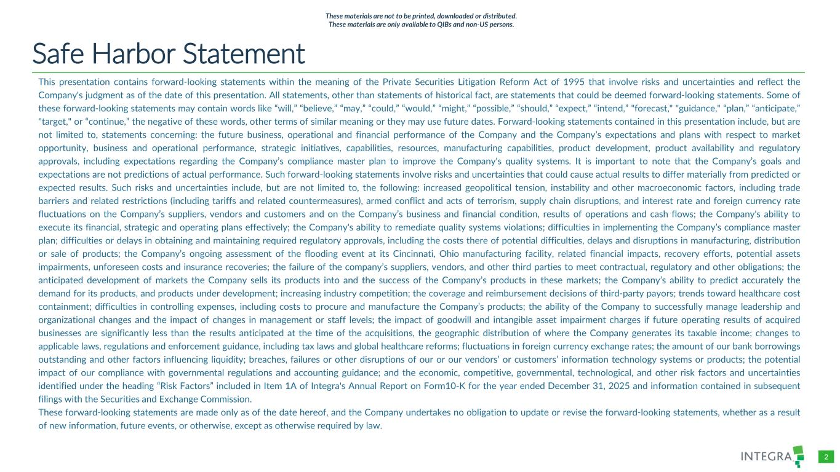
COLOR PALETTE Text 31 73 125 Title bar/Bullets 31 59 83 ACCENTS 1 31 59 83 140 179 212 2 30 105 142 143 202 231 3 47 177 52 165 231 167 4 54 132 156 166 210 224 5 140 181 202 209 225 234 6 191 191 191 229 229 229 Hyperlink 31 59 83 140 179 212 Followed Hyperlink 30 105 142 143 202 231 Lines 31 73 125 Highlights 31 59 83 TABLE 2 These materials are not to be printed, downloaded or distributed. These materials are only available to QIBs and non-US persons. Safe Harbor Statement This presentation contains forward-looking statements within the meaning of the Private Securities Litigation Reform Act of 1995 that involve risks and uncertainties and reflect the Company's judgment as of the date of this presentation. All statements, other than statements of historical fact, are statements that could be deemed forward-looking statements. Some of these forward-looking statements may contain words like “will,” “believe,” “may,” “could,” “would,” “might,” “possible,” “should,” “expect,” “intend,” "forecast," "guidance," “plan,” “anticipate,” "target," or “continue,” the negative of these words, other terms of similar meaning or they may use future dates. Forward-looking statements contained in this presentation include, but are not limited to, statements concerning: the future business, operational and financial performance of the Company and the Company’s expectations and plans with respect to market opportunity, business and operational performance, strategic initiatives, capabilities, resources, manufacturing capabilities, product development, product availability and regulatory approvals, including expectations regarding the Company’s compliance master plan to improve the Company's quality systems. It is important to note that the Company’s goals and expectations are not predictions of actual performance. Such forward-looking statements involve risks and uncertainties that could cause actual results to differ materially from predicted or expected results. Such risks and uncertainties include, but are not limited to, the following: increased geopolitical tension, instability and other macroeconomic factors, including trade barriers and related restrictions (including tariffs and related countermeasures), armed conflict and acts of terrorism, supply chain disruptions, and interest rate and foreign currency rate fluctuations on the Company’s suppliers, vendors and customers and on the Company’s business and financial condition, results of operations and cash flows; the Company's ability to execute its financial, strategic and operating plans effectively; the Company's ability to remediate quality systems violations; difficulties in implementing the Company’s compliance master plan; difficulties or delays in obtaining and maintaining required regulatory approvals, including the costs there of potential difficulties, delays and disruptions in manufacturing, distribution or sale of products; the Company’s ongoing assessment of the flooding event at its Cincinnati, Ohio manufacturing facility, related financial impacts, recovery efforts, potential assets impairments, unforeseen costs and insurance recoveries; the failure of the company’s suppliers, vendors, and other third parties to meet contractual, regulatory and other obligations; the anticipated development of markets the Company sells its products into and the success of the Company’s products in these markets; the Company’s ability to predict accurately the demand for its products, and products under development; increasing industry competition; the coverage and reimbursement decisions of third-party payors; trends toward healthcare cost containment; difficulties in controlling expenses, including costs to procure and manufacture the Company’s products; the ability of the Company to successfully manage leadership and organizational changes and the impact of changes in management or staff levels; the impact of goodwill and intangible asset impairment charges if future operating results of acquired businesses are significantly less than the results anticipated at the time of the acquisitions, the geographic distribution of where the Company generates its taxable income; changes to applicable laws, regulations and enforcement guidance, including tax laws and global healthcare reforms; fluctuations in foreign currency exchange rates; the amount of our bank borrowings outstanding and other factors influencing liquidity; breaches, failures or other disruptions of our or our vendors’ or customers’ information technology systems or products; the potential impact of our compliance with governmental regulations and accounting guidance; and the economic, competitive, governmental, technological, and other risk factors and uncertainties identified under the heading “Risk Factors” included in Item 1A of Integra's Annual Report on Form10-K for the year ended December 31, 2025 and information contained in subsequent filings with the Securities and Exchange Commission. These forward-looking statements are made only as of the date hereof, and the Company undertakes no obligation to update or revise the forward-looking statements, whether as a result of new information, future events, or otherwise, except as otherwise required by law.

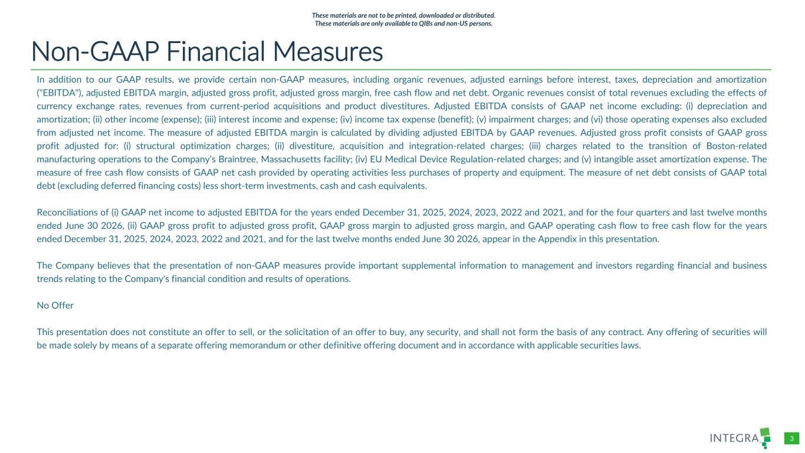
COLOR PALETTE Text 31 73 125 Title bar/Bullets 31 59 83 ACCENTS 1 31 59 83 140 179 212 2 30 105 142 143 202 231 3 47 177 52 165 231 167 4 54 132 156 166 210 224 5 140 181 202 209 225 234 6 191 191 191 229 229 229 Hyperlink 31 59 83 140 179 212 Followed Hyperlink 30 105 142 143 202 231 Lines 31 73 125 Highlights 31 59 83 TABLE 3 These materials are not to be printed, downloaded or distributed. These materials are only available to QIBs and non-US persons. Non-GAAP Financial Measures In addition to our GAAP results, we provide certain non-GAAP measures, including organic revenues, adjusted earnings before interest, taxes, depreciation and amortization ("EBITDA"), adjusted EBITDA margin, adjusted gross profit, adjusted gross margin, free cash flow and net debt. Organic revenues consist of total revenues excluding the effects of currency exchange rates, revenues from current-period acquisitions and product divestitures. Adjusted EBITDA consists of GAAP net income excluding: (i) depreciation and amortization; (ii) other income (expense); (iii) interest income and expense; (iv) income tax expense (benefit); (v) impairment charges; and (vi) those operating expenses also excluded from adjusted net income. The measure of adjusted EBITDA margin is calculated by dividing adjusted EBITDA by GAAP revenues. Adjusted gross profit consists of GAAP gross profit adjusted for: (i) structural optimization charges; (ii) divestiture, acquisition and integration-related charges; (iii) charges related to the transition of Boston-related manufacturing operations to the Company’s Braintree, Massachusetts facility; (iv) EU Medical Device Regulation-related charges; and (v) intangible asset amortization expense. The measure of free cash flow consists of GAAP net cash provided by operating activities less purchases of property and equipment. The measure of net debt consists of GAAP total debt (excluding deferred financing costs) less short-term investments, cash and cash equivalents. Reconciliations of (i) GAAP net income to adjusted EBITDA for the years ended December 31, 2025, 2024, 2023, 2022 and 2021, and for the four quarters and last twelve months ended June 30 2026, (ii) GAAP gross profit to adjusted gross profit, GAAP gross margin to adjusted gross margin, and GAAP operating cash flow to free cash flow for the years ended December 31, 2025, 2024, 2023, 2022 and 2021, and for the last twelve months ended June 30 2026, appear in the Appendix in this presentation. The Company believes that the presentation of non-GAAP measures provide important supplemental information to management and investors regarding financial and business trends relating to the Company's financial condition and results of operations. No Offer This presentation does not constitute an offer to sell, or the solicitation of an offer to buy, any security, and shall not form the basis of any contract. Any offering of securities will be made solely by means of a separate offering memorandum or other definitive offering document and in accordance with applicable securities laws.

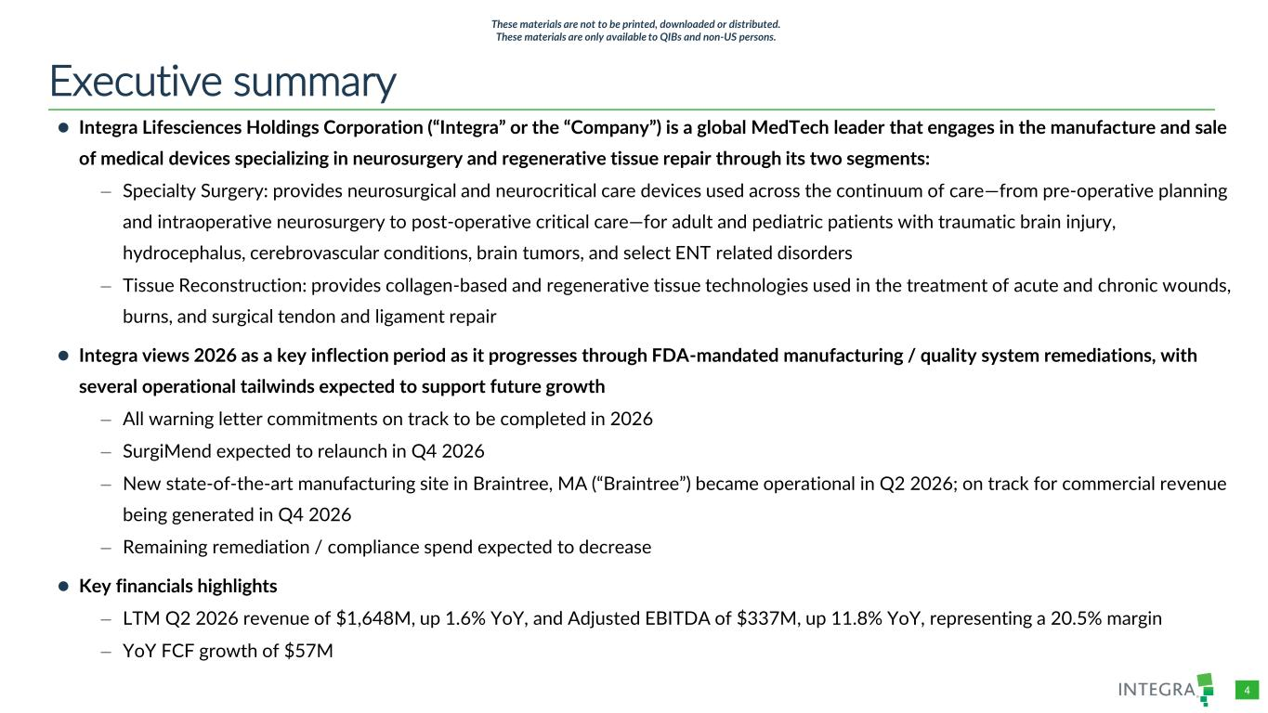
COLOR PALETTE Text 31 73 125 Title bar/Bullets 31 59 83 ACCENTS 1 31 59 83 140 179 212 2 30 105 142 143 202 231 3 47 177 52 165 231 167 4 54 132 156 166 210 224 5 140 181 202 209 225 234 6 191 191 191 229 229 229 Hyperlink 31 59 83 140 179 212 Followed Hyperlink 30 105 142 143 202 231 Lines 31 73 125 Highlights 31 59 83 TABLE 4 Executive summary ⚫ Integra Lifesciences Holdings Corporation (“Integra” or the “Company”) is a global MedTech leader that engages in the manufacture and sale of medical devices specializing in neurosurgery and regenerative tissue repair through its two segments: – Specialty Surgery: provides neurosurgical and neurocritical care devices used across the continuum of care—from pre-operative planning and intraoperative neurosurgery to post-operative critical care—for adult and pediatric patients with traumatic brain injury, hydrocephalus, cerebrovascular conditions, brain tumors, and select ENT related disorders – Tissue Reconstruction: provides collagen-based and regenerative tissue technologies used in the treatment of acute and chronic wounds, burns, and surgical tendon and ligament repair ⚫ Integra views 2026 as a key inflection period as it progresses through FDA-mandated manufacturing / quality system remediations, with several operational tailwinds expected to support future growth – All warning letter commitments on track to be completed in 2026 – SurgiMend expected to relaunch in Q4 2026 – New state-of-the-art manufacturing site in Braintree, MA (“Braintree”) became operational in Q2 2026; on track for commercial revenue being generated in Q4 2026 – Remaining remediation / compliance spend expected to decrease ⚫ Key financials highlights – LTM Q2 2026 revenue of $1,648M, up 1.6% YoY, and Adjusted EBITDA of $337M, up 11.8% YoY, representing a 20.5% margin – YoY FCF growth of $57M These materials are not to be printed, downloaded or distributed. These materials are only available to QIBs and non-US persons.


/Admin/ADVANCED GRAPHICS FILES/Cover and Template/2026/2026_03/4714660-001_Integra_Chelsea Lin_Dividers Business overview 01 These materials are not to be printed, downloaded or distributed. These materials are only available to QIBs and non-US persons.

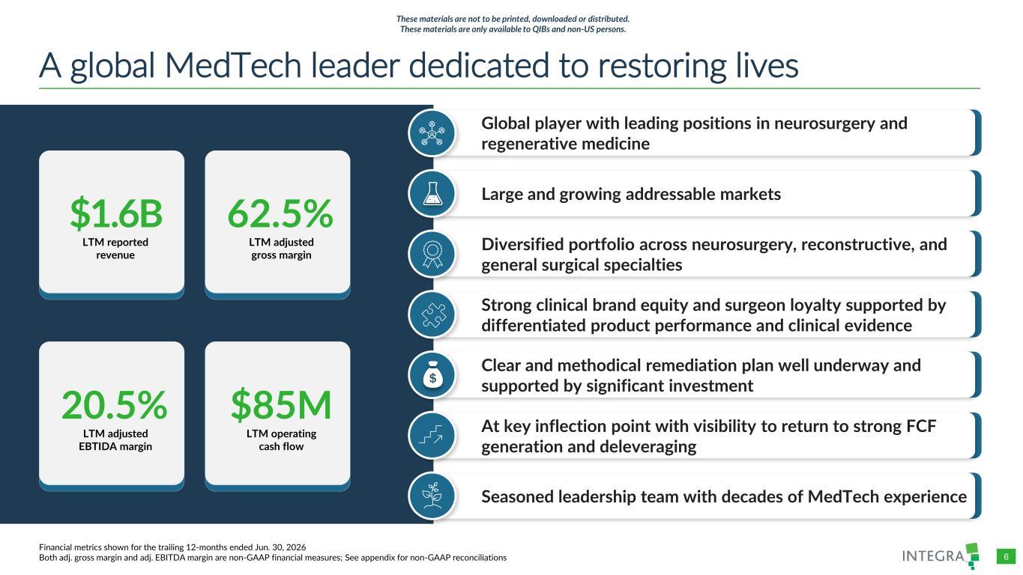
COLOR PALETTE Text 31 73 125 Title bar/Bullets 31 59 83 ACCENTS 1 31 59 83 140 179 212 2 30 105 142 143 202 231 3 47 177 52 165 231 167 4 54 132 156 166 210 224 5 140 181 202 209 225 234 6 191 191 191 229 229 229 Hyperlink 31 59 83 140 179 212 Followed Hyperlink 30 105 142 143 202 231 Lines 31 73 125 Highlights 31 59 83 TABLE 6 A global MedTech leader dedicated to restoring lives Financial metrics shown for the trailing 12-months ended Jun. 30, 2026 Both adj. gross margin and adj. EBITDA margin are non-GAAP financial measures; See appendix for non-GAAP reconciliations 20.5% LTM adjusted EBTIDA margin 62.5% LTM adjusted gross margin $1.6B LTM reported revenue $85M LTM operating cash flow Global player with leading positions in neurosurgery and regenerative medicine Large and growing addressable markets Strong clinical brand equity and surgeon loyalty supported by differentiated product performance and clinical evidence Seasoned leadership team with decades of MedTech experience At key inflection point with visibility to return to strong FCF generation and deleveraging These materials are not to be printed, downloaded or distributed. These materials are only available to QIBs and non-US persons. Diversified portfolio across neurosurgery, reconstructive, and general surgical specialties Clear and methodical remediation plan well underway and supported by significant investment

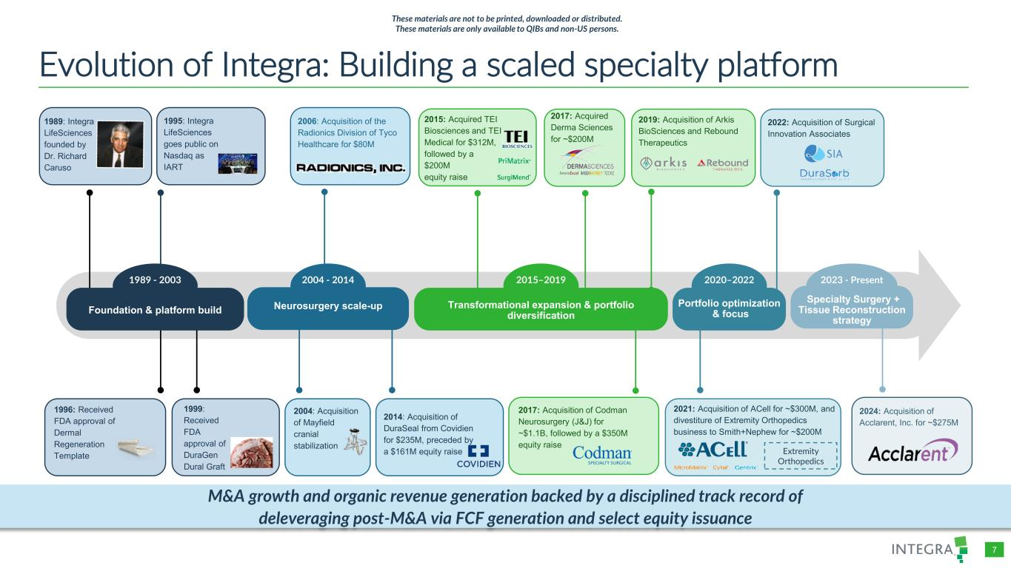
COLOR PALETTE Text 31 73 125 Title bar/Bullets 31 59 83 ACCENTS 1 31 59 83 140 179 212 2 30 105 142 143 202 231 3 47 177 52 165 231 167 4 54 132 156 166 210 224 5 140 181 202 209 225 234 6 191 191 191 229 229 229 Hyperlink 31 59 83 140 179 212 Followed Hyperlink 30 105 142 143 202 231 Lines 31 73 125 Highlights 31 59 83 TABLE 7 Evolution of Integra: Building a scaled specialty platform 1989: Integra LifeSciences founded by Dr. Richard Caruso 2015–2019 2020–2022 2023 - Present Transformational expansion & portfolio diversification Portfolio optimization & focus 2004 - 2014 Neurosurgery scale-up 1996: Received FDA approval of Dermal Regeneration Template 1989 - 2003 Foundation & platform build 1999: Received FDA approval of DuraGen Dural Graft 1995: Integra LifeSciences goes public on Nasdaq as IART 2006: Acquisition of the Radionics Division of Tyco Healthcare for $80M 2015: Acquired TEI Biosciences and TEI Medical for $312M, followed by a $200M equity raise 2022: Acquisition of Surgical Innovation Associates Specialty Surgery + Tissue Reconstruction strategy 2024: Acquisition of Acclarent, Inc. for ~$275M 2004: Acquisition of Mayfield cranial stabilization 2014: Acquisition of DuraSeal from Covidien for $235M, preceded by a $161M equity raise 2017: Acquired Derma Sciences for ~$200M M&A growth and organic revenue generation backed by a disciplined track record of deleveraging post-M&A via FCF generation and select equity issuance 2021: Acquisition of ACell for ~$300M, and divestiture of Extremity Orthopedics business to Smith+Nephew for ~$200M Extremity Orthopedics M&A growth and organic revenue generation backed by a disciplined track record of deleveraging post-M&A via FCF generation and select equity issuance These materials are not to be printed, downloaded or distributed. These materials are only available to QIBs and non-US persons. 2019: Acquisition of Arkis BioSciences and Rebound Therapeutics 2017: Acquisition of Codman Neurosurgery (J&J) for ~$1.1B, followed by a $350M equity raise

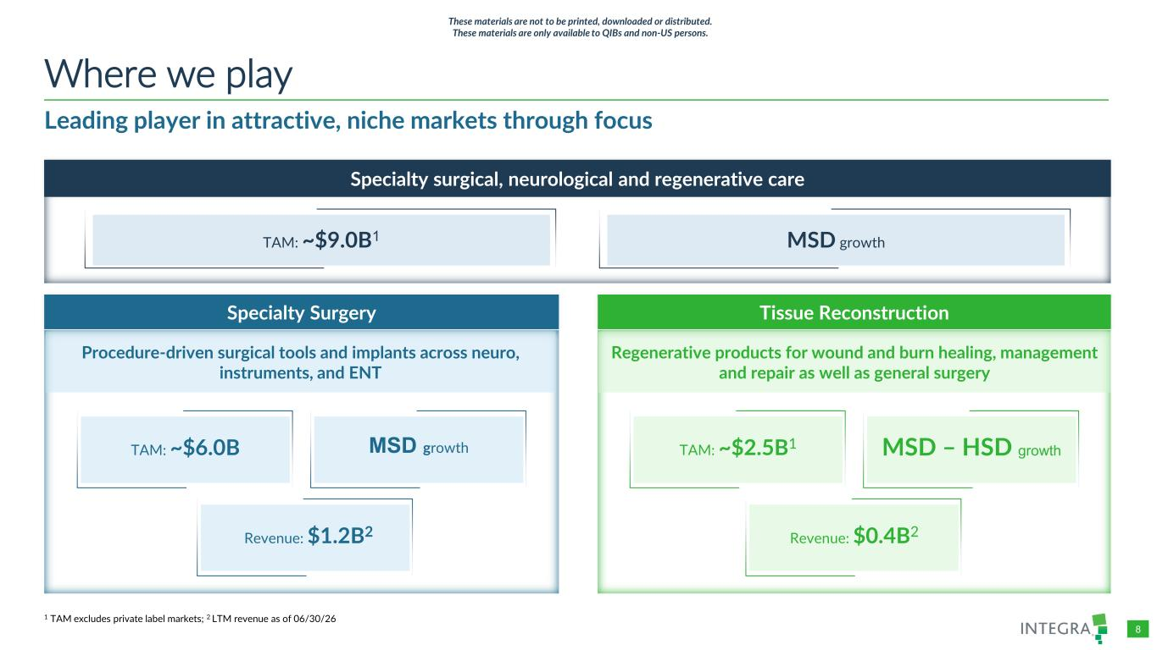
COLOR PALETTE Text 31 73 125 Title bar/Bullets 31 59 83 ACCENTS 1 31 59 83 140 179 212 2 30 105 142 143 202 231 3 47 177 52 165 231 167 4 54 132 156 166 210 224 5 140 181 202 209 225 234 6 191 191 191 229 229 229 Hyperlink 31 59 83 140 179 212 Followed Hyperlink 30 105 142 143 202 231 Lines 31 73 125 Highlights 31 59 83 TABLE 8 Leading player in attractive, niche markets through focus Where we play 1 TAM excludes private label markets; 2 LTM revenue as of 06/30/26 Specialty surgical, neurological and regenerative care Specialty Surgery Tissue Reconstruction TAM: ~$9.0B1 MSD growth TAM: ~$6.0B MSD growth MSD – HSD growthTAM: ~$2.5B1 Revenue: $1.2B2 Revenue: $0.4B2 Procedure-driven surgical tools and implants across neuro, instruments, and ENT Regenerative products for wound and burn healing, management and repair as well as general surgery These materials are not to be printed, downloaded or distributed. These materials are only available to QIBs and non-US persons.

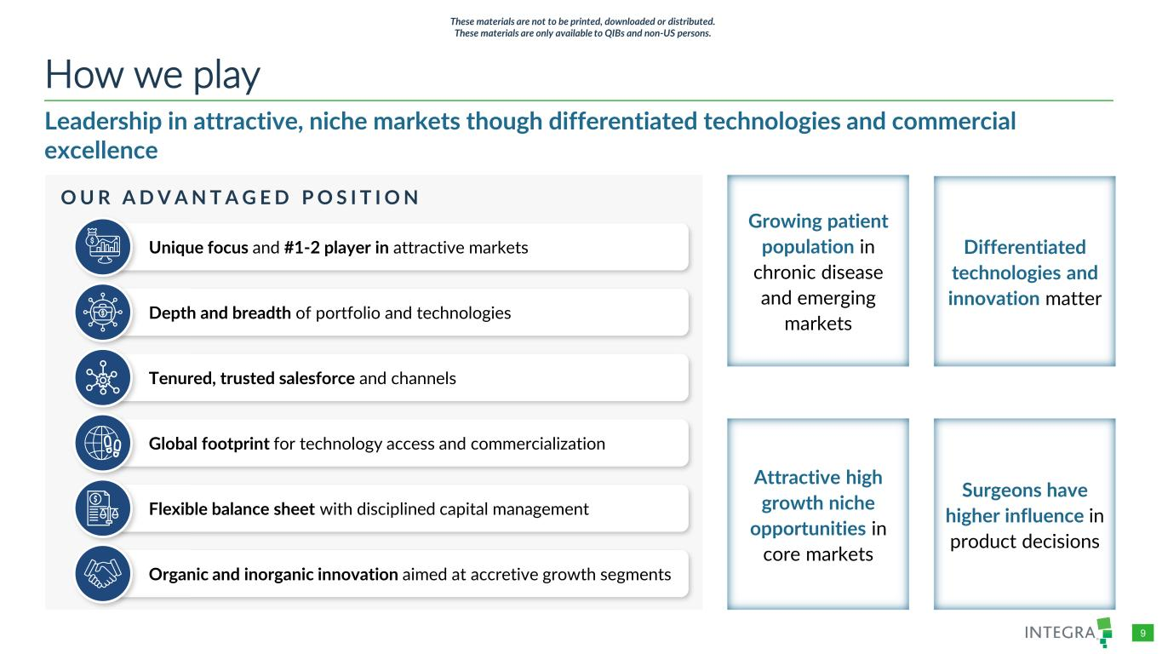
COLOR PALETTE Text 31 73 125 Title bar/Bullets 31 59 83 ACCENTS 1 31 59 83 140 179 212 2 30 105 142 143 202 231 3 47 177 52 165 231 167 4 54 132 156 166 210 224 5 140 181 202 209 225 234 6 191 191 191 229 229 229 Hyperlink 31 59 83 140 179 212 Followed Hyperlink 30 105 142 143 202 231 Lines 31 73 125 Highlights 31 59 83 TABLE 9 Leadership in attractive, niche markets though differentiated technologies and commercial excellence How we play Growing patient population in chronic disease and emerging markets Differentiated technologies and innovation matter O U R A D V A N T A G E D P O S I T I O N Unique focus and #1-2 player in attractive markets Depth and breadth of portfolio and technologies Tenured, trusted salesforce and channels Flexible balance sheet with disciplined capital management Organic and inorganic innovation aimed at accretive growth segments Global footprint for technology access and commercialization Attractive high growth niche opportunities in core markets Surgeons have higher influence in product decisions These materials are not to be printed, downloaded or distributed. These materials are only available to QIBs and non-US persons.

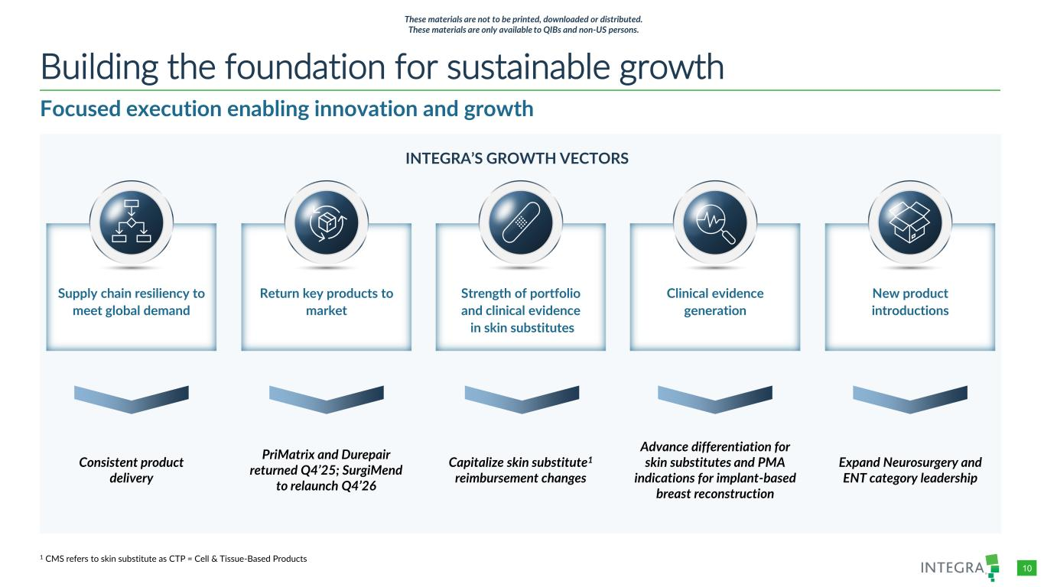
COLOR PALETTE Text 31 73 125 Title bar/Bullets 31 59 83 ACCENTS 1 31 59 83 140 179 212 2 30 105 142 143 202 231 3 47 177 52 165 231 167 4 54 132 156 166 210 224 5 140 181 202 209 225 234 6 191 191 191 229 229 229 Hyperlink 31 59 83 140 179 212 Followed Hyperlink 30 105 142 143 202 231 Lines 31 73 125 Highlights 31 59 83 TABLE 10 Focused execution enabling innovation and growth Building the foundation for sustainable growth INTEGRA’S GROWTH VECTORS New product introductions Expand Neurosurgery and ENT category leadership Clinical evidence generation Advance differentiation for skin substitutes and PMA indications for implant-based breast reconstruction Strength of portfolio and clinical evidence in skin substitutes Capitalize skin substitute1 reimbursement changes Return key products to market PriMatrix and Durepair returned Q4’25; SurgiMend to relaunch Q4’26 Supply chain resiliency to meet global demand Consistent product delivery 1 CMS refers to skin substitute as CTP = Cell & Tissue-Based Products These materials are not to be printed, downloaded or distributed. These materials are only available to QIBs and non-US persons.

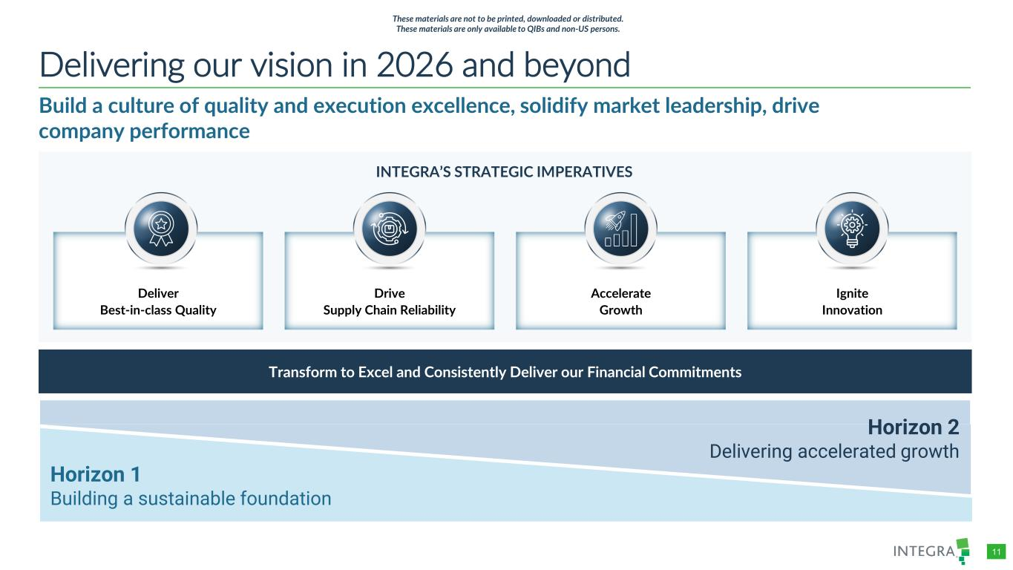
COLOR PALETTE Text 31 73 125 Title bar/Bullets 31 59 83 ACCENTS 1 31 59 83 140 179 212 2 30 105 142 143 202 231 3 47 177 52 165 231 167 4 54 132 156 166 210 224 5 140 181 202 209 225 234 6 191 191 191 229 229 229 Hyperlink 31 59 83 140 179 212 Followed Hyperlink 30 105 142 143 202 231 Lines 31 73 125 Highlights 31 59 83 TABLE 11 Build a culture of quality and execution excellence, solidify market leadership, drive company performance Delivering our vision in 2026 and beyond INTEGRA’S STRATEGIC IMPERATIVES Deliver Best-in-class Quality Drive Supply Chain Reliability Accelerate Growth Ignite Innovation Transform to Excel and Consistently Deliver our Financial Commitments Horizon 2 Delivering accelerated growth Horizon 1 Building a sustainable foundation These materials are not to be printed, downloaded or distributed. These materials are only available to QIBs and non-US persons.


/Admin/ADVANCED GRAPHICS FILES/Cover and Template/2026/2026_03/4714660-001_Integra_Chelsea Lin_Dividers Specialty Surgery 02 These materials are not to be printed, downloaded or distributed. These materials are only available to QIBs and non-US persons.

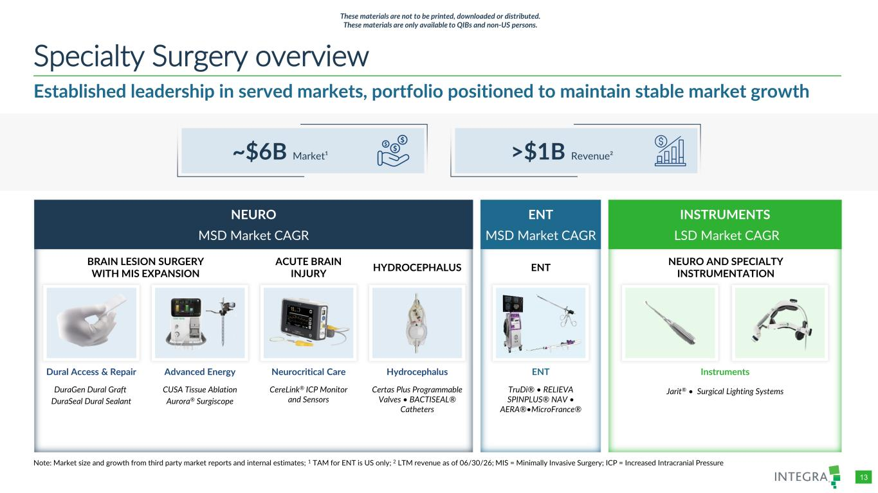
COLOR PALETTE Text 31 73 125 Title bar/Bullets 31 59 83 ACCENTS 1 31 59 83 140 179 212 2 30 105 142 143 202 231 3 47 177 52 165 231 167 4 54 132 156 166 210 224 5 140 181 202 209 225 234 6 191 191 191 229 229 229 Hyperlink 31 59 83 140 179 212 Followed Hyperlink 30 105 142 143 202 231 Lines 31 73 125 Highlights 31 59 83 TABLE 13 ENT MSD Market CAGR Established leadership in served markets, portfolio positioned to maintain stable market growth Specialty Surgery overview Note: Market size and growth from third party market reports and internal estimates; 1 TAM for ENT is US only; 2 LTM revenue as of 06/30/26; MIS = Minimally Invasive Surgery; ICP = Increased Intracranial Pressure NEURO MSD Market CAGR INSTRUMENTS LSD Market CAGR ENT TruDi® • RELIEVA SPINPLUS® NAV • AERA®•MicroFrance® Instruments Jarit® • Surgical Lighting Systems Dural Access & Repair DuraGen Dural Graft DuraSeal Dural Sealant Advanced Energy CUSA Tissue Ablation Aurora® Surgiscope Neurocritical Care CereLink® ICP Monitor and Sensors Hydrocephalus Certas Plus Programmable Valves • BACTISEAL® Catheters BRAIN LESION SURGERY WITH MIS EXPANSION ACUTE BRAIN INJURY HYDROCEPHALUS ENT NEURO AND SPECIALTY INSTRUMENTATION ~$6B Market¹ >$1B Revenue² These materials are not to be printed, downloaded or distributed. These materials are only available to QIBs and non-US persons.

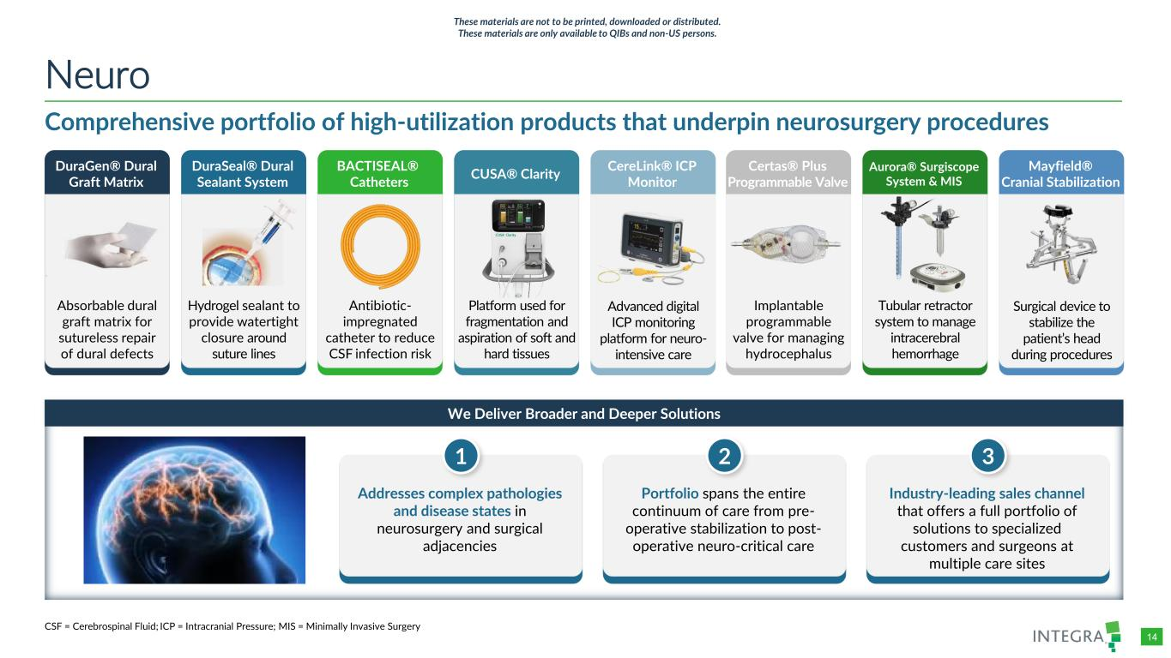
COLOR PALETTE Text 31 73 125 Title bar/Bullets 31 59 83 ACCENTS 1 31 59 83 140 179 212 2 30 105 142 143 202 231 3 47 177 52 165 231 167 4 54 132 156 166 210 224 5 140 181 202 209 225 234 6 191 191 191 229 229 229 Hyperlink 31 59 83 140 179 212 Followed Hyperlink 30 105 142 143 202 231 Lines 31 73 125 Highlights 31 59 83 TABLE 14 We Deliver Broader and Deeper Solutions Comprehensive portfolio of high-utilization products that underpin neurosurgery procedures Neuro Addresses complex pathologies and disease states in neurosurgery and surgical adjacencies 1 Portfolio spans the entire continuum of care from pre- operative stabilization to post- operative neuro-critical care 2 Industry-leading sales channel that offers a full portfolio of solutions to specialized customers and surgeons at multiple care sites 3 DuraGen® Dural Graft Matrix DuraSeal® Dural Sealant System BACTISEAL® Catheters CUSA® Clarity CereLink® ICP Monitor Hydrogel sealant to provide watertight closure around suture lines Antibiotic- impregnated catheter to reduce CSF infection risk Absorbable dural graft matrix for sutureless repair of dural defects Platform used for fragmentation and aspiration of soft and hard tissues Advanced digital ICP monitoring platform for neuro- intensive care Certas® Plus Programmable Valve Aurora® Surgiscope System & MIS Mayfield® Cranial Stabilization Implantable programmable valve for managing hydrocephalus Tubular retractor system to manage intracerebral hemorrhage Surgical device to stabilize the patient’s head during procedures CSF = Cerebrospinal Fluid; ICP = Intracranial Pressure; MIS = Minimally Invasive Surgery These materials are not to be printed, downloaded or distributed. These materials are only available to QIBs and non-US persons.

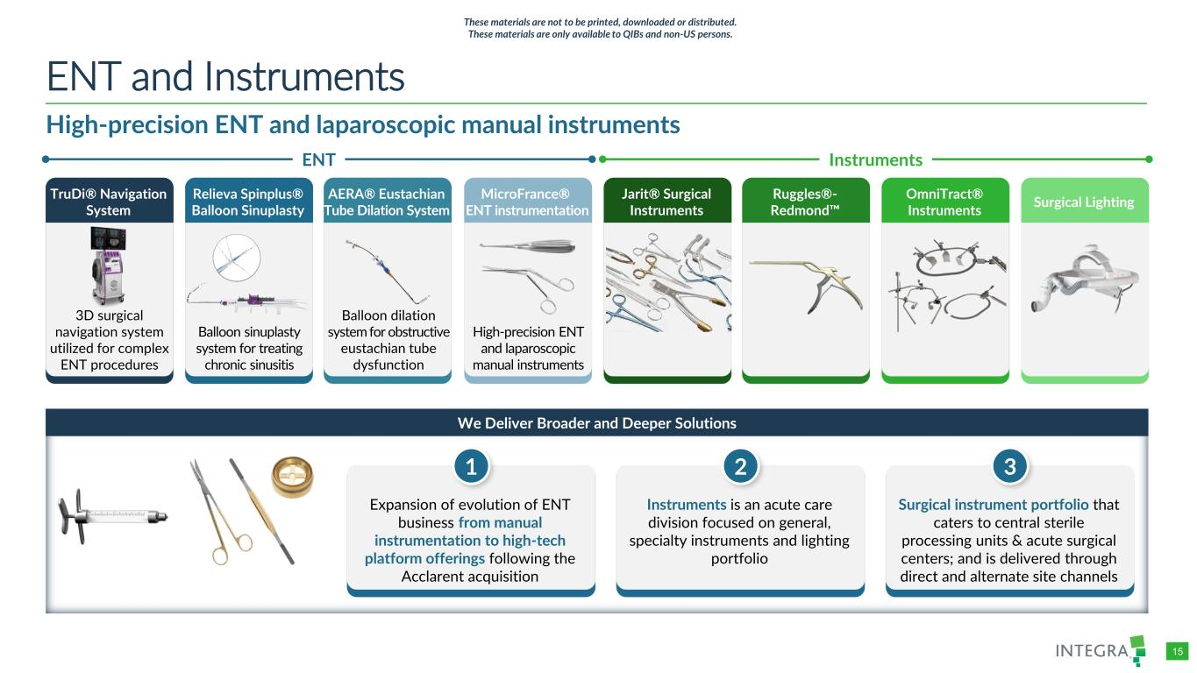
COLOR PALETTE Text 31 73 125 Title bar/Bullets 31 59 83 ACCENTS 1 31 59 83 140 179 212 2 30 105 142 143 202 231 3 47 177 52 165 231 167 4 54 132 156 166 210 224 5 140 181 202 209 225 234 6 191 191 191 229 229 229 Hyperlink 31 59 83 140 179 212 Followed Hyperlink 30 105 142 143 202 231 Lines 31 73 125 Highlights 31 59 83 TABLE 15 We Deliver Broader and Deeper Solutions High-precision ENT and laparoscopic manual instruments ENT and Instruments Expansion of evolution of ENT business from manual instrumentation to high-tech platform offerings following the Acclarent acquisition 1 Instruments is an acute care division focused on general, specialty instruments and lighting portfolio 2 Surgical instrument portfolio that caters to central sterile processing units & acute surgical centers; and is delivered through direct and alternate site channels 3 TruDi® Navigation System Relieva Spinplus® Balloon Sinuplasty AERA® Eustachian Tube Dilation System MicroFrance® ENT instrumentation Jarit® Surgical Instruments Balloon sinuplasty system for treating chronic sinusitis Balloon dilation system for obstructive eustachian tube dysfunction 3D surgical navigation system utilized for complex ENT procedures High-precision ENT and laparoscopic manual instruments Ruggles®- Redmond OmniTract® Instruments Surgical Lighting ENT Instruments These materials are not to be printed, downloaded or distributed. These materials are only available to QIBs and non-US persons.

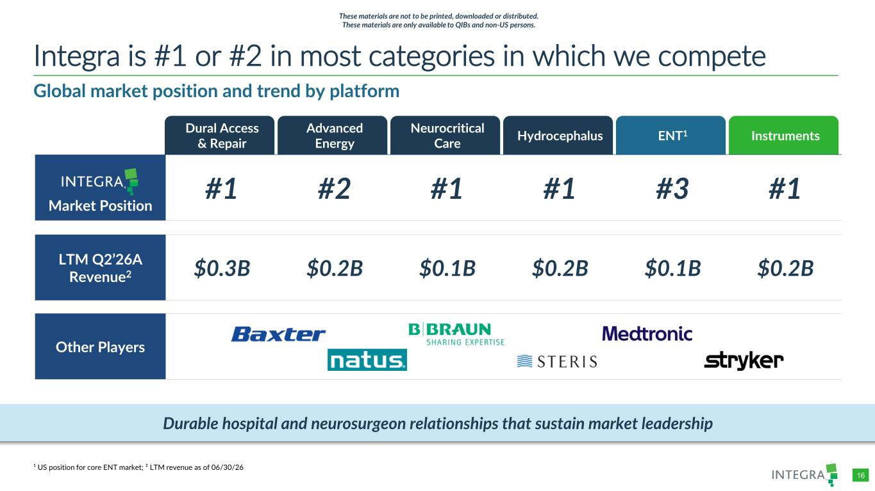
COLOR PALETTE Text 31 73 125 Title bar/Bullets 31 59 83 ACCENTS 1 31 59 83 140 179 212 2 30 105 142 143 202 231 3 47 177 52 165 231 167 4 54 132 156 166 210 224 5 140 181 202 209 225 234 6 191 191 191 229 229 229 Hyperlink 31 59 83 140 179 212 Followed Hyperlink 30 105 142 143 202 231 Lines 31 73 125 Highlights 31 59 83 TABLE 16 Dural Access & Repair Advanced Energy Neurocritical Care Hydrocephalus ENT1 Instruments Market Position #1 #2 #1 #1 #3 #1 LTM Q2’26A Revenue2 $0.3B $0.2B $0.1B $0.2B $0.1B $0.2B Other Players Global market position and trend by platform Integra is #1 or #2 in most categories in which we compete ¹ US position for core ENT market; ² LTM revenue as of 06/30/26 Durable hospital and neurosurgeon relationships that sustain market leadership These materials are not to be printed, downloaded or distributed. These materials are only available to QIBs and non-US persons.

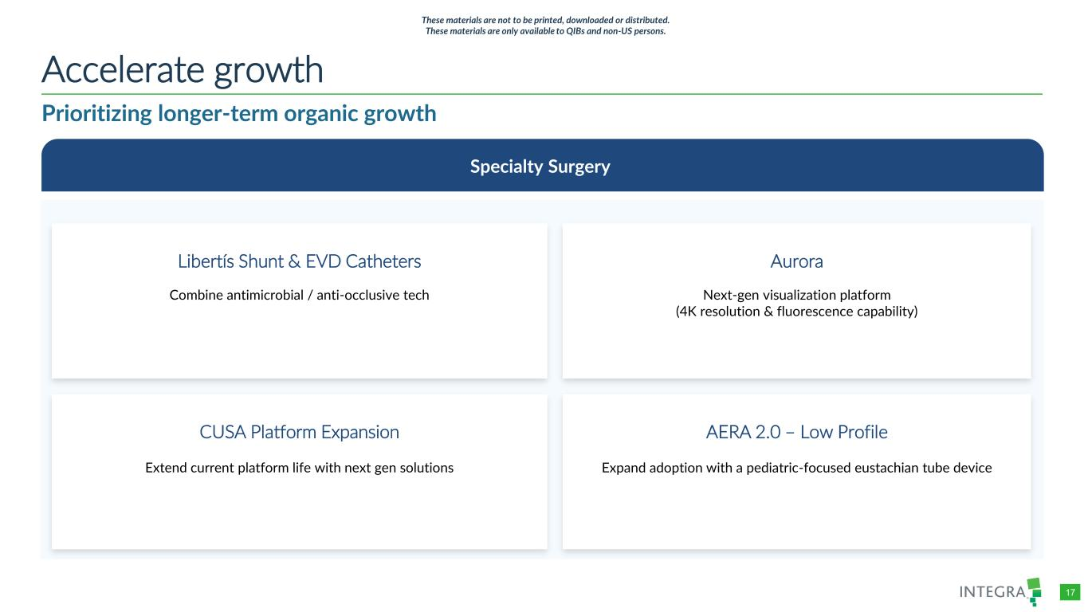
COLOR PALETTE Text 31 73 125 Title bar/Bullets 31 59 83 ACCENTS 1 31 59 83 140 179 212 2 30 105 142 143 202 231 3 47 177 52 165 231 167 4 54 132 156 166 210 224 5 140 181 202 209 225 234 6 191 191 191 229 229 229 Hyperlink 31 59 83 140 179 212 Followed Hyperlink 30 105 142 143 202 231 Lines 31 73 125 Highlights 31 59 83 TABLE 17 Accelerate growth Specialty Surgery CUSA Platform Expansion Extend current platform life with next gen solutions AERA 2.0 – Low Profile Expand adoption with a pediatric-focused eustachian tube device Libertís Shunt & EVD Catheters Combine antimicrobial / anti-occlusive tech Aurora Next-gen visualization platform (4K resolution & fluorescence capability) Prioritizing longer-term organic growth These materials are not to be printed, downloaded or distributed. These materials are only available to QIBs and non-US persons.

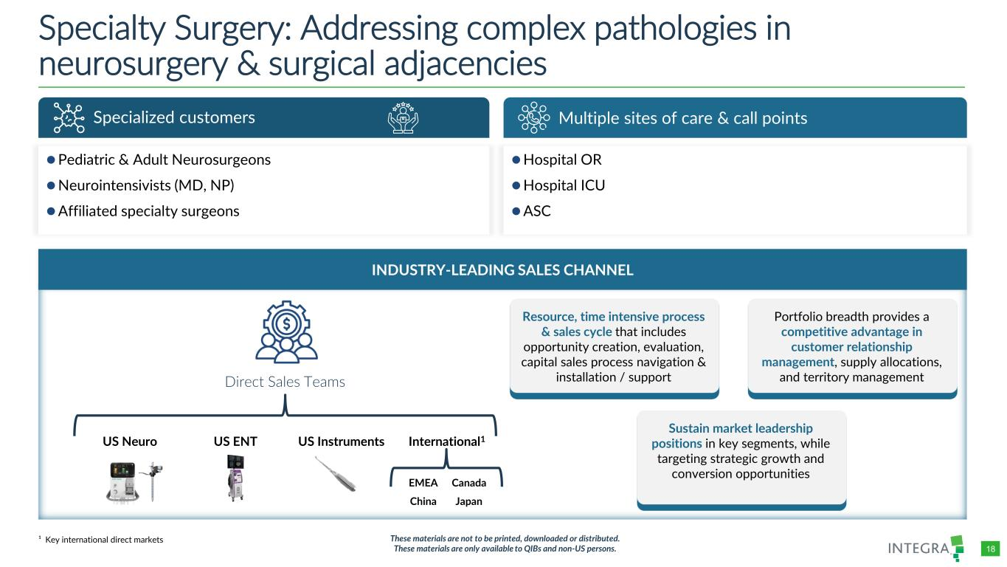
COLOR PALETTE Text 31 73 125 Title bar/Bullets 31 59 83 ACCENTS 1 31 59 83 140 179 212 2 30 105 142 143 202 231 3 47 177 52 165 231 167 4 54 132 156 166 210 224 5 140 181 202 209 225 234 6 191 191 191 229 229 229 Hyperlink 31 59 83 140 179 212 Followed Hyperlink 30 105 142 143 202 231 Lines 31 73 125 Highlights 31 59 83 TABLE 18 Specialty Surgery: Addressing complex pathologies in neurosurgery & surgical adjacencies Specialized customers ⚫Pediatric & Adult Neurosurgeons ⚫Neurointensivists (MD, NP) ⚫Affiliated specialty surgeons Multiple sites of care & call points ⚫Hospital OR ⚫Hospital ICU ⚫ASC ¹ Key international direct markets These materials are not to be printed, downloaded or distributed. These materials are only available to QIBs and non-US persons. INDUSTRY-LEADING SALES CHANNEL Direct Sales Teams US Neuro US ENT US Instruments International1 EMEA Canada China Japan Sustain market leadership positions in key segments, while targeting strategic growth and conversion opportunities Resource, time intensive process & sales cycle that includes opportunity creation, evaluation, capital sales process navigation & installation / support Portfolio breadth provides a competitive advantage in customer relationship management, supply allocations, and territory management

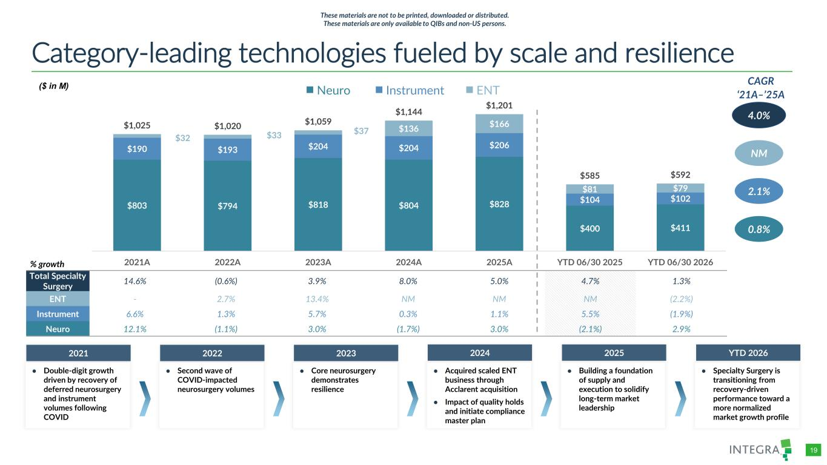
COLOR PALETTE Text 31 73 125 Title bar/Bullets 31 59 83 ACCENTS 1 31 59 83 140 179 212 2 30 105 142 143 202 231 3 47 177 52 165 231 167 4 54 132 156 166 210 224 5 140 181 202 209 225 234 6 191 191 191 229 229 229 Hyperlink 31 59 83 140 179 212 Followed Hyperlink 30 105 142 143 202 231 Lines 31 73 125 Highlights 31 59 83 TABLE 19 $803 $794 $818 $804 $828 $400 $411 $190 $193 $204 $204 $206 $104 $102 $32 $33 $37 $136 $166 $81 $79 $1,025 $1,020 $1,059 $1,144 $1,201 $585 $592 2021A 2022A 2023A 2024A 2025A YTD 06/30 2025 YTD 06/30 2026 Category-leading technologies fueled by scale and resilience 0.8% 2.1% NM CAGR ‘21A–’25A 4.0% 1 Neuro Instrument ENT Total Specialty Surgery 14.6% (0.6%) 3.9% 8.0% 5.0% 4.7% 1.3% ENT - 2.7% 13.4% NM NM NM (2.2%) Instrument 6.6% 1.3% 5.7% 0.3% 1.1% 5.5% (1.9%) Neuro 12.1% (1.1%) 3.0% (1.7%) 3.0% (2.1%) 2.9% % growth ● Double-digit growth driven by recovery of deferred neurosurgery and instrument volumes following COVID 2021 ● Second wave of COVID-impacted neurosurgery volumes 2022 ● Core neurosurgery demonstrates resilience 2023 ● Acquired scaled ENT business through Acclarent acquisition ● Impact of quality holds and initiate compliance master plan 2024 ● Building a foundation of supply and execution to solidify long-term market leadership 2025 ($ in M) These materials are not to be printed, downloaded or distributed. These materials are only available to QIBs and non-US persons. ● Specialty Surgery is transitioning from recovery-driven performance toward a more normalized market growth profile YTD 2026

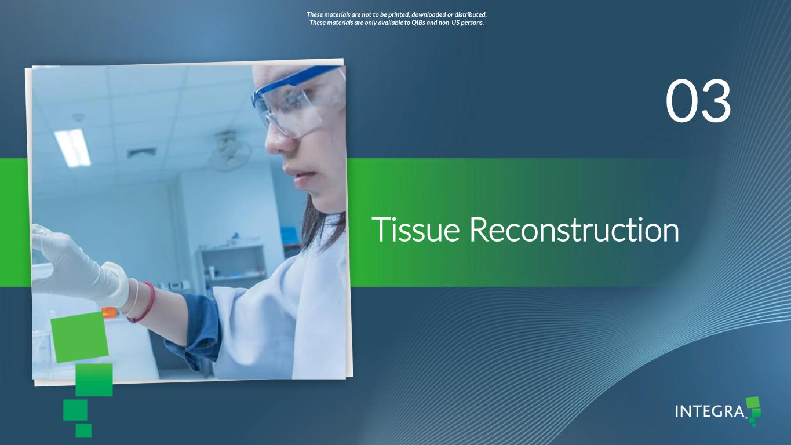
/Admin/ADVANCED GRAPHICS FILES/Cover and Template/2026/2026_03/4714660-001_Integra_Chelsea Lin_Dividers Tissue Reconstruction 03 These materials are not to be printed, downloaded or distributed. These materials are only available to QIBs and non-US persons.

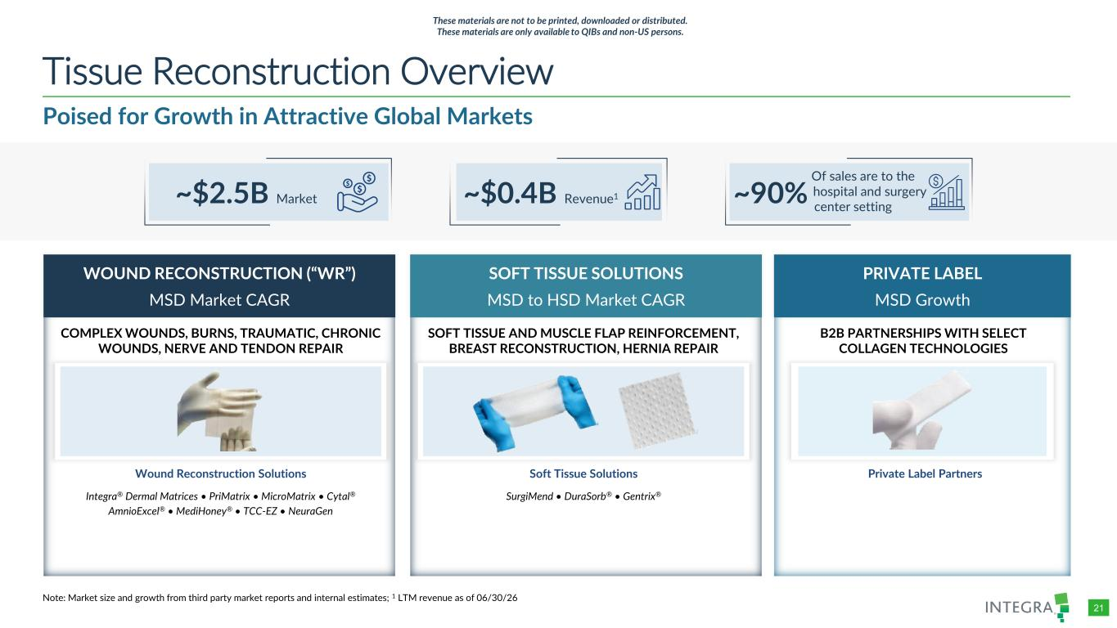
COLOR PALETTE Text 31 73 125 Title bar/Bullets 31 59 83 ACCENTS 1 31 59 83 140 179 212 2 30 105 142 143 202 231 3 47 177 52 165 231 167 4 54 132 156 166 210 224 5 140 181 202 209 225 234 6 191 191 191 229 229 229 Hyperlink 31 59 83 140 179 212 Followed Hyperlink 30 105 142 143 202 231 Lines 31 73 125 Highlights 31 59 83 TABLE 21 Poised for Growth in Attractive Global Markets Tissue Reconstruction Overview Note: Market size and growth from third party market reports and internal estimates; 1 LTM revenue as of 06/30/26 WOUND RECONSTRUCTION (“WR”) MSD Market CAGR PRIVATE LABEL MSD Growth Wound Reconstruction Solutions Integra® Dermal Matrices • PriMatrix • MicroMatrix • Cytal® AmnioExcel® • MediHoney® • TCC-EZ • NeuraGen COMPLEX WOUNDS, BURNS, TRAUMATIC, CHRONIC WOUNDS, NERVE AND TENDON REPAIR B2B PARTNERSHIPS WITH SELECT COLLAGEN TECHNOLOGIES ~$2.5B Market SOFT TISSUE SOLUTIONS MSD to HSD Market CAGR Soft Tissue Solutions SurgiMend • DuraSorb® • Gentrix® SOFT TISSUE AND MUSCLE FLAP REINFORCEMENT, BREAST RECONSTRUCTION, HERNIA REPAIR Private Label Partners ~$0.4B Revenue1 ~90% Of sales are to the hospital and surgery center setting These materials are not to be printed, downloaded or distributed. These materials are only available to QIBs and non-US persons.

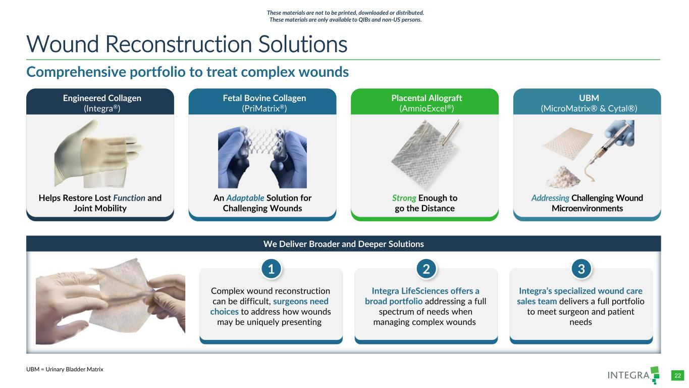
COLOR PALETTE Text 31 73 125 Title bar/Bullets 31 59 83 ACCENTS 1 31 59 83 140 179 212 2 30 105 142 143 202 231 3 47 177 52 165 231 167 4 54 132 156 166 210 224 5 140 181 202 209 225 234 6 191 191 191 229 229 229 Hyperlink 31 59 83 140 179 212 Followed Hyperlink 30 105 142 143 202 231 Lines 31 73 125 Highlights 31 59 83 TABLE 22 UBM (MicroMatrix® & Cytal®) Addressing Challenging Wound Microenvironments We Deliver Broader and Deeper Solutions Comprehensive portfolio to treat complex wounds Wound Reconstruction Solutions UBM = Urinary Bladder Matrix Fetal Bovine Collagen (PriMatrix®) An Adaptable Solution for Challenging Wounds Engineered Collagen (Integra®) Helps Restore Lost Function and Joint Mobility Placental Allograft (AmnioExcel®) Strong Enough to go the Distance Complex wound reconstruction can be difficult, surgeons need choices to address how wounds may be uniquely presenting 1 Integra LifeSciences offers a broad portfolio addressing a full spectrum of needs when managing complex wounds 2 Integra’s specialized wound care sales team delivers a full portfolio to meet surgeon and patient needs 3 These materials are not to be printed, downloaded or distributed. These materials are only available to QIBs and non-US persons.

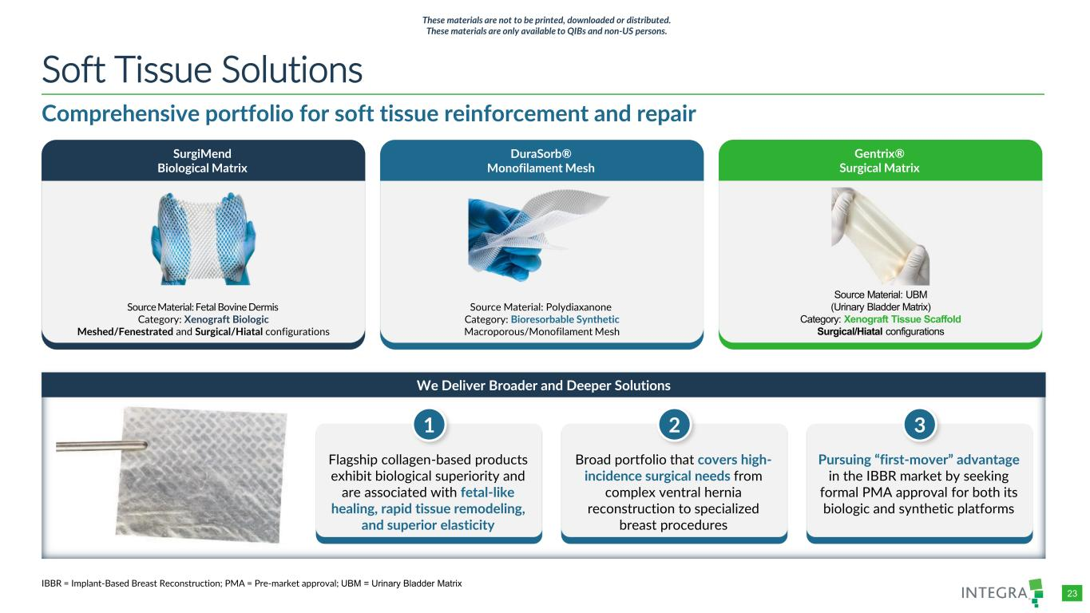
COLOR PALETTE Text 31 73 125 Title bar/Bullets 31 59 83 ACCENTS 1 31 59 83 140 179 212 2 30 105 142 143 202 231 3 47 177 52 165 231 167 4 54 132 156 166 210 224 5 140 181 202 209 225 234 6 191 191 191 229 229 229 Hyperlink 31 59 83 140 179 212 Followed Hyperlink 30 105 142 143 202 231 Lines 31 73 125 Highlights 31 59 83 TABLE 23 DuraSorb® Monofilament Mesh Source Material: Polydiaxanone Category: Bioresorbable Synthetic Macroporous/Monofilament Mesh SurgiMend Biological Matrix Source Material: Fetal Bovine Dermis Category: Xenograft Biologic Meshed/Fenestrated and Surgical/Hiatal configurations Comprehensive portfolio for soft tissue reinforcement and repair Soft Tissue Solutions We Deliver Broader and Deeper Solutions Flagship collagen-based products exhibit biological superiority and are associated with fetal-like healing, rapid tissue remodeling, and superior elasticity 1 Broad portfolio that covers high- incidence surgical needs from complex ventral hernia reconstruction to specialized breast procedures 2 Pursuing “first-mover” advantage in the IBBR market by seeking formal PMA approval for both its biologic and synthetic platforms 3 IBBR = Implant-Based Breast Reconstruction; PMA = Pre-market approval; UBM = Urinary Bladder Matrix Gentrix® Surgical Matrix Source Material: UBM (Urinary Bladder Matrix) Category: Xenograft Tissue Scaffold Surgical/Hiatal configurations These materials are not to be printed, downloaded or distributed. These materials are only available to QIBs and non-US persons.

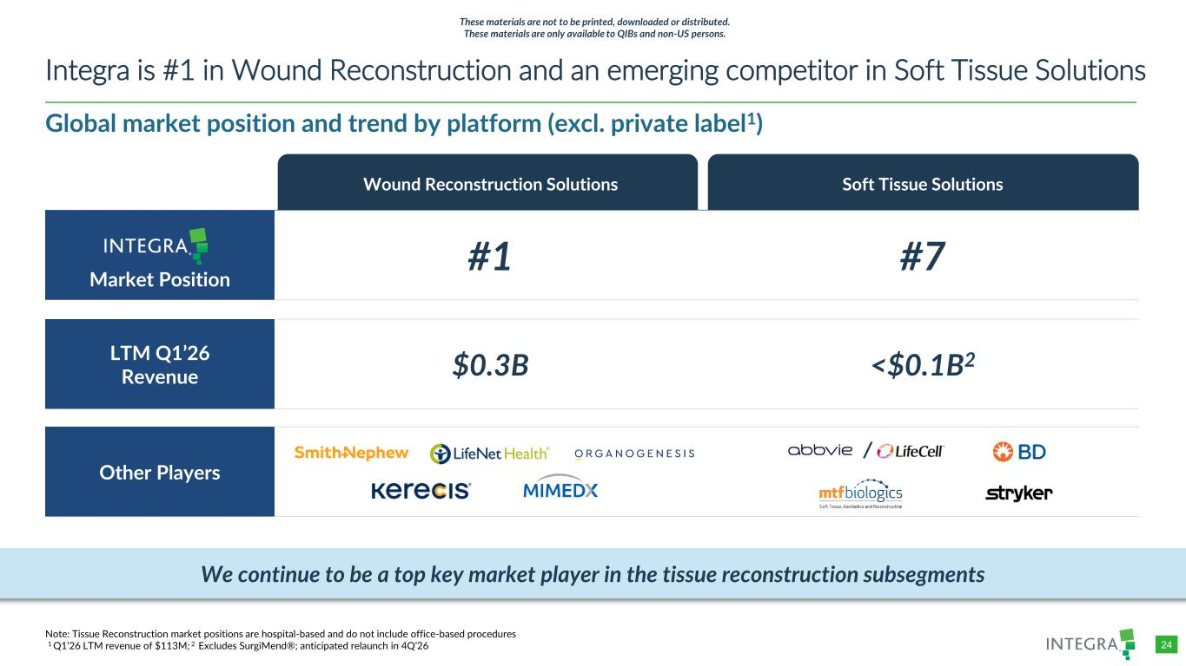
COLOR PALETTE Text 31 73 125 Title bar/Bullets 31 59 83 ACCENTS 1 31 59 83 140 179 212 2 30 105 142 143 202 231 3 47 177 52 165 231 167 4 54 132 156 166 210 224 5 140 181 202 209 225 234 6 191 191 191 229 229 229 Hyperlink 31 59 83 140 179 212 Followed Hyperlink 30 105 142 143 202 231 Lines 31 73 125 Highlights 31 59 83 TABLE 24 Global market position and trend by platform (excl. private label1) Integra is #1 in Wound Reconstruction and an emerging competitor in Soft Tissue Solutions Note: Tissue Reconstruction market positions are hospital-based and do not include office-based procedures 1 Q1’26 LTM revenue of $113M; 2 Excludes SurgiMend®; anticipated relaunch in 4Q’26 Wound Reconstruction Solutions Soft Tissue Solutions Market Position #1 #7 LTM Q1’26 Revenue $0.3B <$0.1B2 Other Players We continue to be a top key market player in the tissue reconstruction subsegments / These materials are not to be printed, downloaded or distributed. These materials are only available to QIBs and non-US persons.

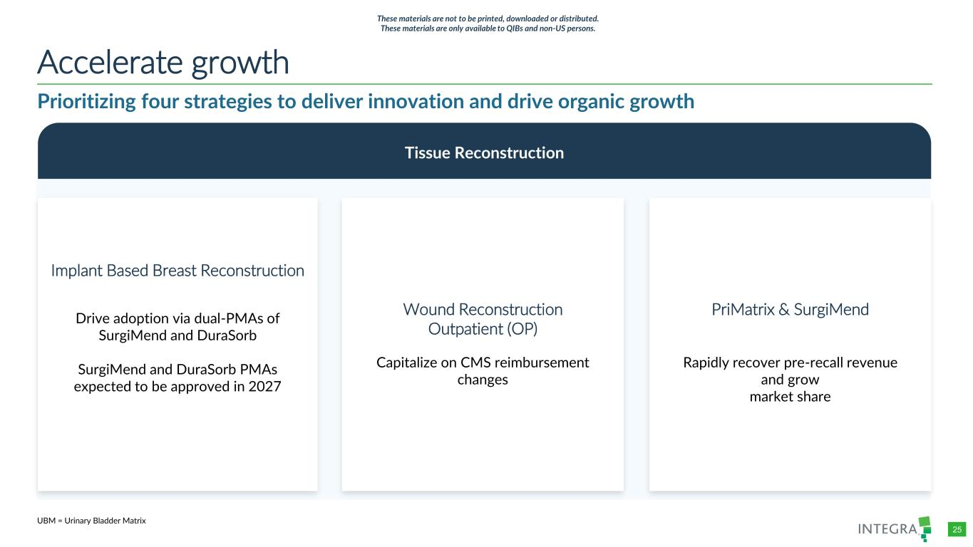
COLOR PALETTE Text 31 73 125 Title bar/Bullets 31 59 83 ACCENTS 1 31 59 83 140 179 212 2 30 105 142 143 202 231 3 47 177 52 165 231 167 4 54 132 156 166 210 224 5 140 181 202 209 225 234 6 191 191 191 229 229 229 Hyperlink 31 59 83 140 179 212 Followed Hyperlink 30 105 142 143 202 231 Lines 31 73 125 Highlights 31 59 83 TABLE 25 Prioritizing four strategies to deliver innovation and drive organic growth Accelerate growth Tissue Reconstruction Wound Reconstruction Outpatient (OP) Capitalize on CMS reimbursement changes PriMatrix & SurgiMend Rapidly recover pre-recall revenue and grow market share Implant Based Breast Reconstruction Drive adoption via dual-PMAs of SurgiMend and DuraSorb SurgiMend and DuraSorb PMAs expected to be approved in 2027 UBM = Urinary Bladder Matrix These materials are not to be printed, downloaded or distributed. These materials are only available to QIBs and non-US persons.

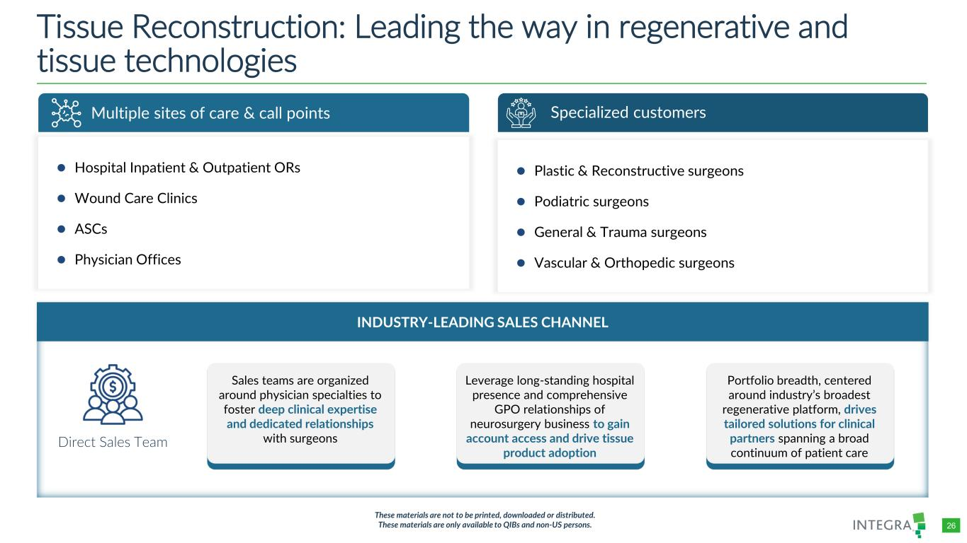
COLOR PALETTE Text 31 73 125 Title bar/Bullets 31 59 83 ACCENTS 1 31 59 83 140 179 212 2 30 105 142 143 202 231 3 47 177 52 165 231 167 4 54 132 156 166 210 224 5 140 181 202 209 225 234 6 191 191 191 229 229 229 Hyperlink 31 59 83 140 179 212 Followed Hyperlink 30 105 142 143 202 231 Lines 31 73 125 Highlights 31 59 83 TABLE 26 Tissue Reconstruction: Leading the way in regenerative and tissue technologies Specialized customers ⚫ Plastic & Reconstructive surgeons ⚫ Podiatric surgeons ⚫ General & Trauma surgeons ⚫ Vascular & Orthopedic surgeons Multiple sites of care & call points ⚫ Hospital Inpatient & Outpatient ORs ⚫ Wound Care Clinics ⚫ ASCs ⚫ Physician Offices INDUSTRY-LEADING SALES CHANNEL Direct Sales Team These materials are not to be printed, downloaded or distributed. These materials are only available to QIBs and non-US persons. Sales teams are organized around physician specialties to foster deep clinical expertise and dedicated relationships with surgeons Leverage long-standing hospital presence and comprehensive GPO relationships of neurosurgery business to gain account access and drive tissue product adoption Portfolio breadth, centered around industry’s broadest regenerative platform, drives tailored solutions for clinical partners spanning a broad continuum of patient care

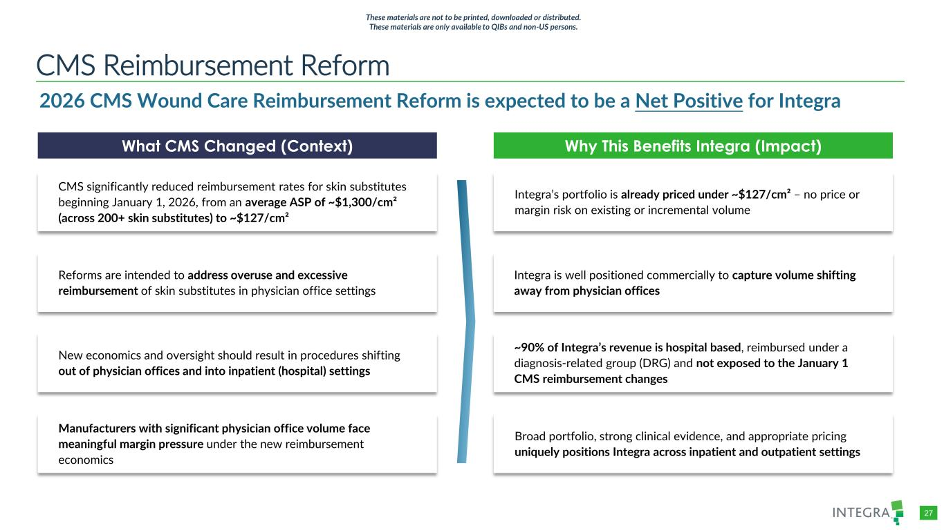
COLOR PALETTE Text 31 73 125 Title bar/Bullets 31 59 83 ACCENTS 1 31 59 83 140 179 212 2 30 105 142 143 202 231 3 47 177 52 165 231 167 4 54 132 156 166 210 224 5 140 181 202 209 225 234 6 191 191 191 229 229 229 Hyperlink 31 59 83 140 179 212 Followed Hyperlink 30 105 142 143 202 231 Lines 31 73 125 Highlights 31 59 83 TABLE 27 CMS Reimbursement Reform 2026 CMS Wound Care Reimbursement Reform is expected to be a Net Positive for Integra Why This Benefits Integra (Impact)What CMS Changed (Context) CMS significantly reduced reimbursement rates for skin substitutes beginning January 1, 2026, from an average ASP of ~$1,300/cm² (across 200+ skin substitutes) to ~$127/cm² Reforms are intended to address overuse and excessive reimbursement of skin substitutes in physician office settings New economics and oversight should result in procedures shifting out of physician offices and into inpatient (hospital) settings Manufacturers with significant physician office volume face meaningful margin pressure under the new reimbursement economics ~90% of Integra’s revenue is hospital based, reimbursed under a diagnosis-related group (DRG) and not exposed to the January 1 CMS reimbursement changes Integra’s portfolio is already priced under ~$127/cm² – no price or margin risk on existing or incremental volume Integra is well positioned commercially to capture volume shifting away from physician offices Broad portfolio, strong clinical evidence, and appropriate pricing uniquely positions Integra across inpatient and outpatient settings These materials are not to be printed, downloaded or distributed. These materials are only available to QIBs and non-US persons.

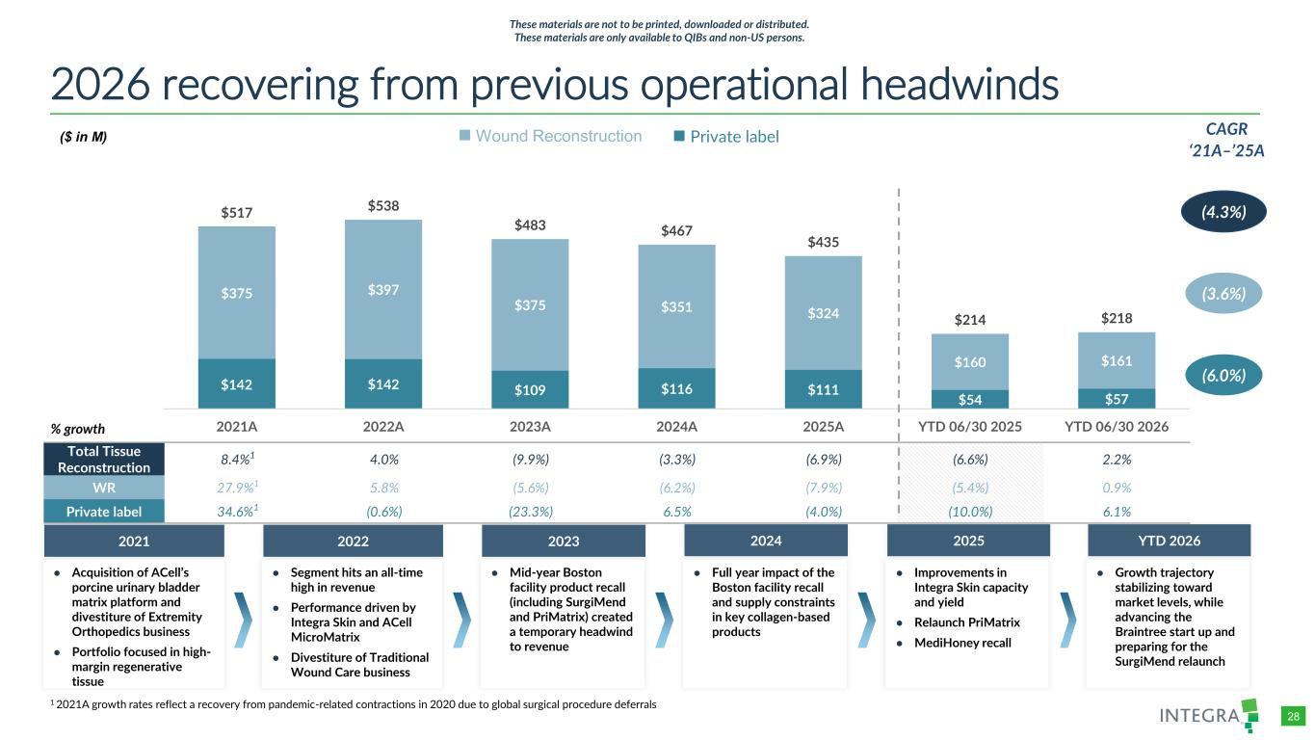
COLOR PALETTE Text 31 73 125 Title bar/Bullets 31 59 83 ACCENTS 1 31 59 83 140 179 212 2 30 105 142 143 202 231 3 47 177 52 165 231 167 4 54 132 156 166 210 224 5 140 181 202 209 225 234 6 191 191 191 229 229 229 Hyperlink 31 59 83 140 179 212 Followed Hyperlink 30 105 142 143 202 231 Lines 31 73 125 Highlights 31 59 83 TABLE 28 2026 recovering from previous operational headwinds 1 % growth ● Acquisition of ACell’s porcine urinary bladder matrix platform and divestiture of Extremity Orthopedics business ● Portfolio focused in high- margin regenerative tissue 2021 ● Segment hits an all-time high in revenue ● Performance driven by Integra Skin and ACell MicroMatrix ● Divestiture of Traditional Wound Care business 2022 ● Mid-year Boston facility product recall (including SurgiMend and PriMatrix) created a temporary headwind to revenue 2023 ● Full year impact of the Boston facility recall and supply constraints in key collagen-based products 2024 ● Growth trajectory stabilizing toward market levels, while advancing the Braintree start up and preparing for the SurgiMend relaunch YTD 2026 (3.6%) CAGR ‘21A–’25A (4.3%) Wound Reconstruction Private label Total Tissue Reconstruction 8.4%1 4.0% (9.9%) (3.3%) (6.9%) (6.6%) 2.2% WR 27.9%1 5.8% (5.6%) (6.2%) (7.9%) (5.4%) 0.9% Private label 34.6%1 (0.6%) (23.3%) 6.5% (4.0%) (10.0%) 6.1% (6.0%) 1 2021A growth rates reflect a recovery from pandemic-related contractions in 2020 due to global surgical procedure deferrals ($ in M) $142 $142 $109 $116 $111 $54 $57 $375 $397 $375 $351 $324 $160 $161 $517 $538 $483 $467 $435 $214 $218 2021A 2022A 2023A 2024A 2025A YTD 06/30 2025 YTD 06/30 2026 These materials are not to be printed, downloaded or distributed. These materials are only available to QIBs and non-US persons. ● Improvements in Integra Skin capacity and yield ● Relaunch PriMatrix ● MediHoney recall 2025

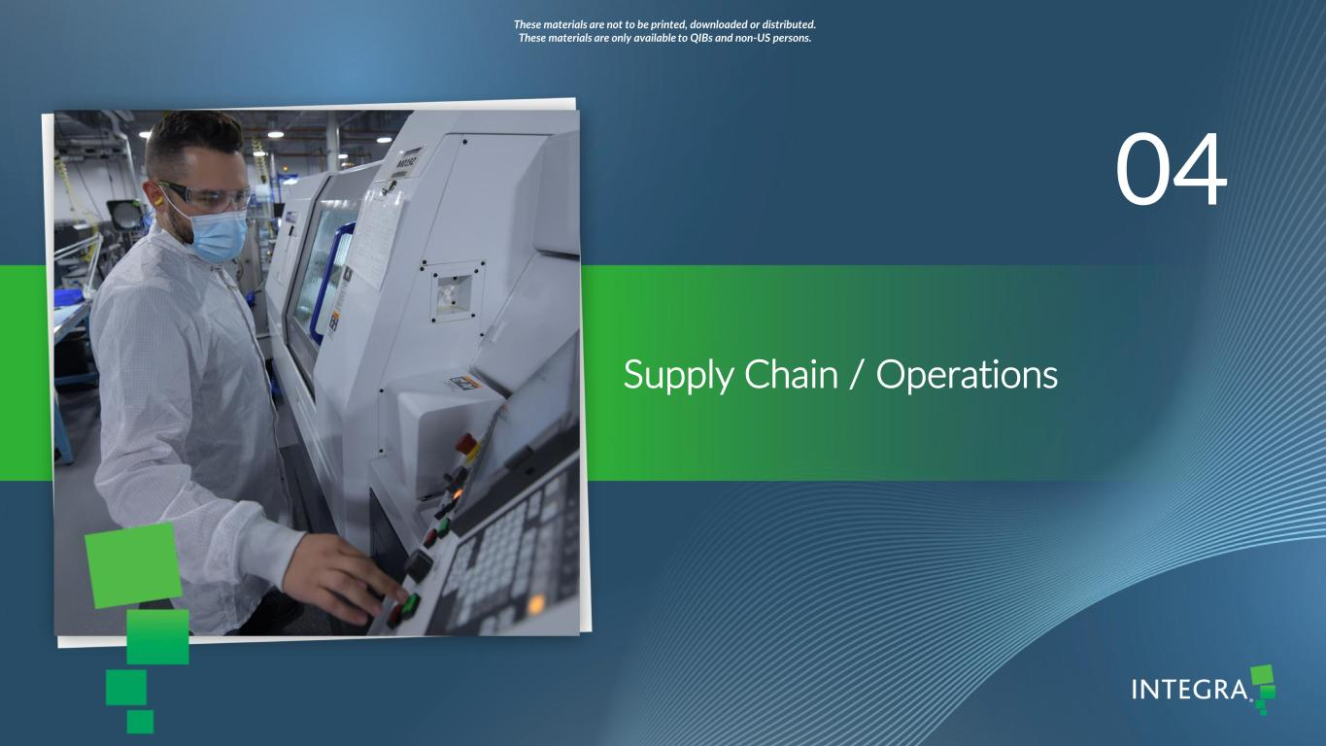
/Admin/ADVANCED GRAPHICS FILES/Cover and Template/2026/2026_03/4714660-001_Integra_Chelsea Lin_Dividers Supply Chain / Operations 04 These materials are not to be printed, downloaded or distributed. These materials are only available to QIBs and non-US persons.

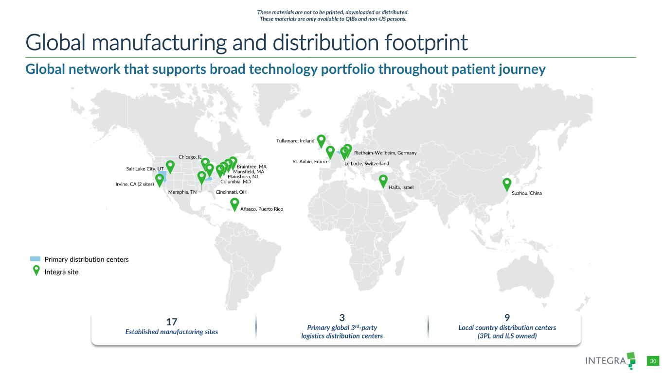
COLOR PALETTE Text 31 73 125 Title bar/Bullets 31 59 83 ACCENTS 1 31 59 83 140 179 212 2 30 105 142 143 202 231 3 47 177 52 165 231 167 4 54 132 156 166 210 224 5 140 181 202 209 225 234 6 191 191 191 229 229 229 Hyperlink 31 59 83 140 179 212 Followed Hyperlink 30 105 142 143 202 231 Lines 31 73 125 Highlights 31 59 83 TABLE 30 Suzhou, China Haifa, Israel Rietheim-Weilheim, Germany Tullamore, Ireland St. Aubin, France Le Locle, Switzerland Añasco, Puerto Rico Mansfield, MA Plainsboro, NJ Columbia, MD Salt Lake City, UT Irvine, CA (2 sites) Memphis, TN Chicago, IL Cincinnati, OH Global manufacturing and distribution footprint Integra site Primary distribution centers 17 Established manufacturing sites 3 Primary global 3rd-party logistics distribution centers 9 Local country distribution centers (3PL and ILS owned) Global network that supports broad technology portfolio throughout patient journey Braintree, MA These materials are not to be printed, downloaded or distributed. These materials are only available to QIBs and non-US persons.

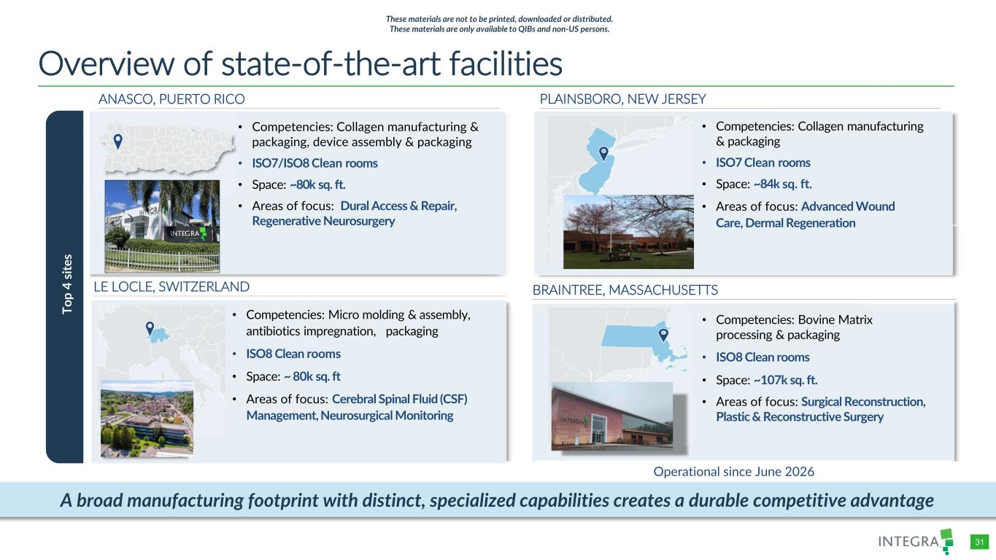
COLOR PALETTE Text 31 73 125 Title bar/Bullets 31 59 83 ACCENTS 1 31 59 83 140 179 212 2 30 105 142 143 202 231 3 47 177 52 165 231 167 4 54 132 156 166 210 224 5 140 181 202 209 225 234 6 191 191 191 229 229 229 Hyperlink 31 59 83 140 179 212 Followed Hyperlink 30 105 142 143 202 231 Lines 31 73 125 Highlights 31 59 83 TABLE 31 Overview of state-of-the-art facilities • Competencies: Bovine Matrix processing & packaging • ISO8 Clean rooms • Space: ~107k sq. ft. • Areas of focus: Surgical Reconstruction, Plastic & Reconstructive Surgery • Competencies: Collagen manufacturing & packaging • ISO7 Clean rooms • Space: ~84k sq. ft. • Areas of focus: Advanced Wound Care, Dermal Regeneration • Competencies: Collagen manufacturing & packaging, device assembly & packaging • ISO7/ISO8 Clean rooms • Space: ~80k sq. ft. • Areas of focus: Dural Access & Repair, Regenerative Neurosurgery T o p 3 S it e s Operational since June 2026 ANASCO, PUERTO RICO • Competencies: Micro molding & assembly, antibiotics impregnation, packaging • ISO8 Clean rooms • Space: ~ 80k sq. ft • Areas of focus: Cerebral Spinal Fluid (CSF) Management, Neurosurgical Monitoring LE LOCLE, SWITZERLAND BRAINTREE, MASSACHUSETTS PLAINSBORO, NEW JERSEY To p 4 si te s A broad manufacturing footprint with distinct, specialized capabilities creates a durable competitive advantage These materials are not to be printed, downloaded or distributed. These materials are only available to QIBs and non-US persons.

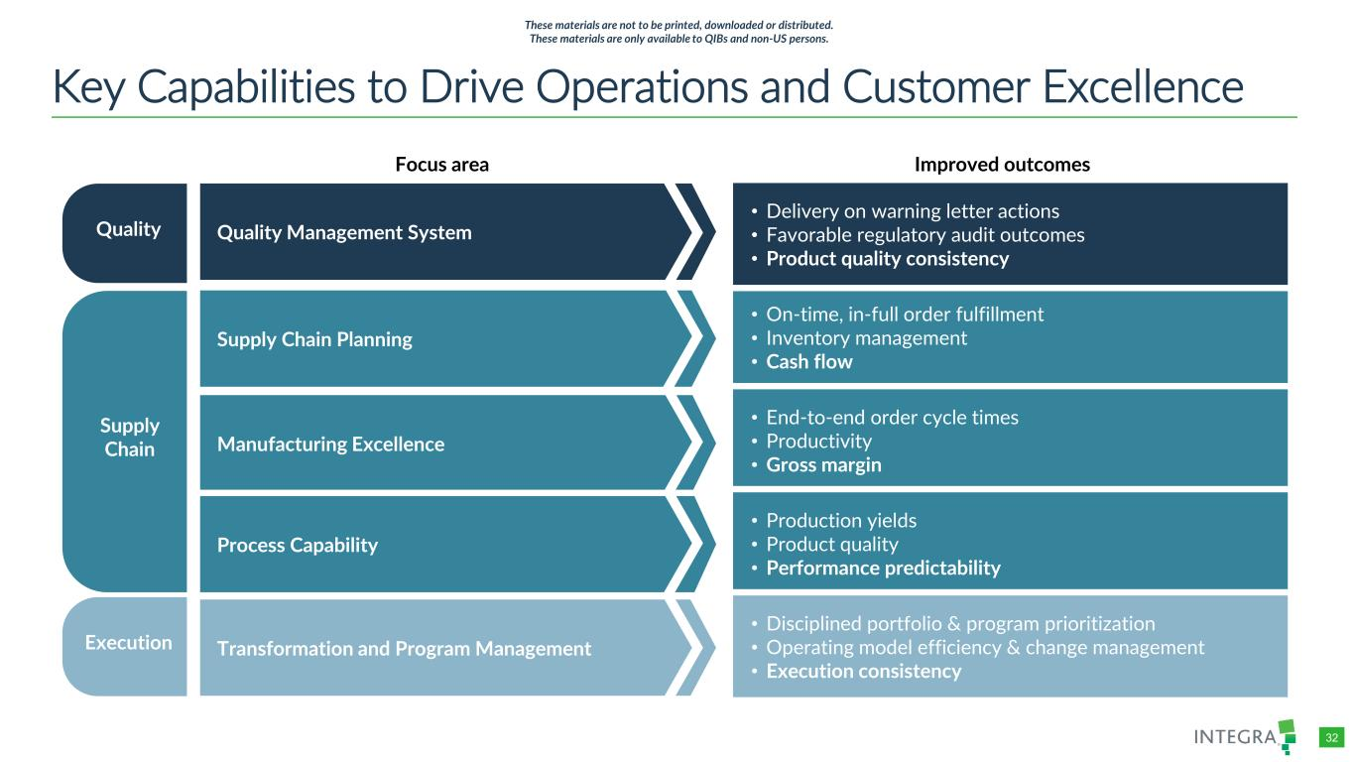
COLOR PALETTE Text 31 73 125 Title bar/Bullets 31 59 83 ACCENTS 1 31 59 83 140 179 212 2 30 105 142 143 202 231 3 47 177 52 165 231 167 4 54 132 156 166 210 224 5 140 181 202 209 225 234 6 191 191 191 229 229 229 Hyperlink 31 59 83 140 179 212 Followed Hyperlink 30 105 142 143 202 231 Lines 31 73 125 Highlights 31 59 83 TABLE 32 Key Capabilities to Drive Operations and Customer Excellence Focus area Improved outcomes • On-time, in-full order fulfillment • Inventory management • Cash flow • End-to-end order cycle times • Productivity • Gross margin • Production yields • Product quality • Performance predictability • Disciplined portfolio & program prioritization • Operating model efficiency & change management • Execution consistency • Delivery on warning letter actions • Favorable regulatory audit outcomes • Product quality consistency Manufacturing Excellence Process Capability Transformation and Program Management Quality Management System Supply Chain Planning Supply Chain Quality Execution These materials are not to be printed, downloaded or distributed. These materials are only available to QIBs and non-US persons.

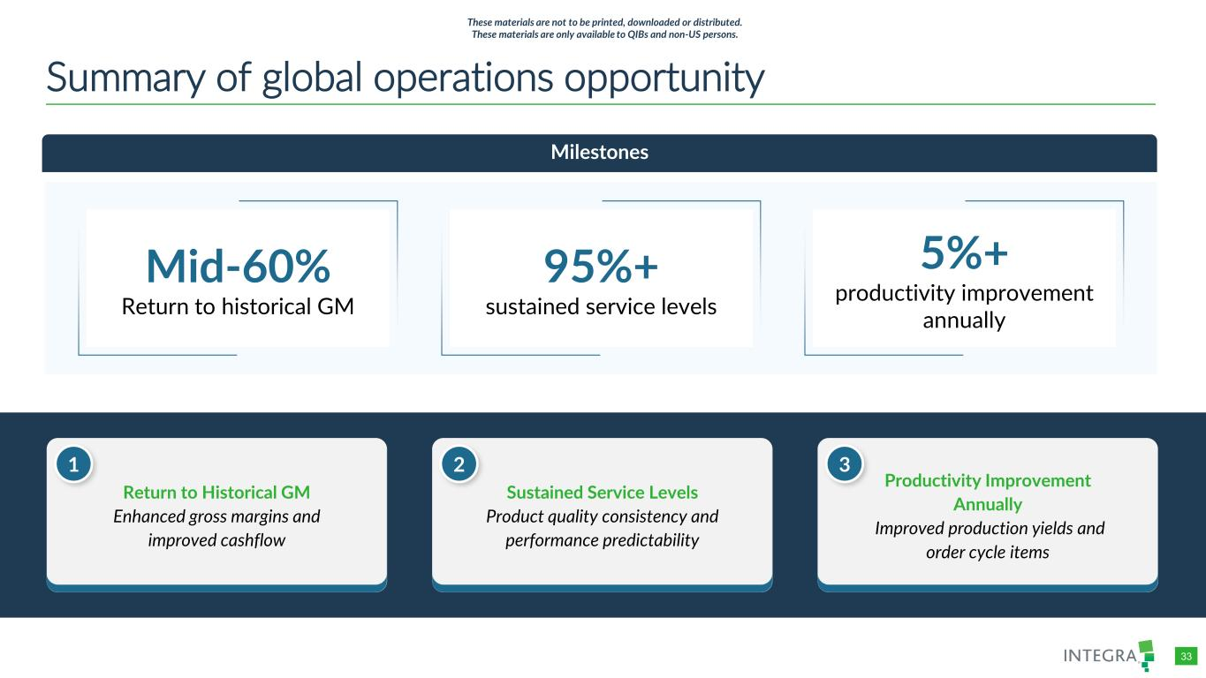
COLOR PALETTE Text 31 73 125 Title bar/Bullets 31 59 83 ACCENTS 1 31 59 83 140 179 212 2 30 105 142 143 202 231 3 47 177 52 165 231 167 4 54 132 156 166 210 224 5 140 181 202 209 225 234 6 191 191 191 229 229 229 Hyperlink 31 59 83 140 179 212 Followed Hyperlink 30 105 142 143 202 231 Lines 31 73 125 Highlights 31 59 83 TABLE 33 Summary of global operations opportunity Milestones Mid-60% Return to historical GM 95%+ sustained service levels 5%+ productivity improvement annually Return to Historical GM Enhanced gross margins and improved cashflow 1 Sustained Service Levels Product quality consistency and performance predictability 2 Productivity Improvement Annually Improved production yields and order cycle items 3 These materials are not to be printed, downloaded or distributed. These materials are only available to QIBs and non-US persons.


/Admin/ADVANCED GRAPHICS FILES/Cover and Template/2026/2026_03/4714660-001_Integra_Chelsea Lin_Dividers Remediation update 05 These materials are not to be printed, downloaded or distributed. These materials are only available to QIBs and non-US persons.

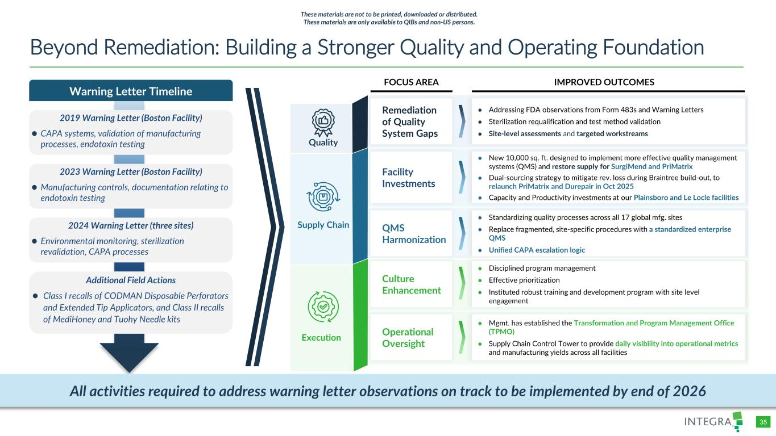
COLOR PALETTE Text 31 73 125 Title bar/Bullets 31 59 83 ACCENTS 1 31 59 83 140 179 212 2 30 105 142 143 202 231 3 47 177 52 165 231 167 4 54 132 156 166 210 224 5 140 181 202 209 225 234 6 191 191 191 229 229 229 Hyperlink 31 59 83 140 179 212 Followed Hyperlink 30 105 142 143 202 231 Lines 31 73 125 Highlights 31 59 83 TABLE 35 Beyond Remediation: Building a Stronger Quality and Operating Foundation Warning Letter Timeline 2019 Warning Letter (Boston Facility) ⚫ CAPA systems, validation of manufacturing processes, endotoxin testing 2023 Warning Letter (Boston Facility) ⚫ Manufacturing controls, documentation relating to endotoxin testing 2024 Warning Letter (three sites) ⚫ Environmental monitoring, sterilization revalidation, CAPA processes Execution Quality Supply Chain Facility Investments ● New 10,000 sq. ft. designed to implement more effective quality management systems (QMS) and restore supply for SurgiMend and PriMatrix ● Dual-sourcing strategy to mitigate rev. loss during Braintree build-out, to relaunch PriMatrix and Durepair in Oct 2025 ● Capacity and Productivity investments at our Plainsboro and Le Locle facilities Remediation of Quality System Gaps ● Addressing FDA observations from Form 483s and Warning Letters ● Sterilization requalification and test method validation ● Site-level assessments and targeted workstreams QMS Harmonization ● Standardizing quality processes across all 17 global mfg. sites ● Replace fragmented, site-specific procedures with a standardized enterprise QMS ● Unified CAPA escalation logic Culture Enhancement ● Disciplined program management ● Effective prioritization ● Instituted robust training and development program with site level engagement Operational Oversight ● Mgmt. has established the Transformation and Program Management Office (TPMO) ● Supply Chain Control Tower to provide daily visibility into operational metrics and manufacturing yields across all facilities FOCUS AREA IMPROVED OUTCOMES Additional Field Actions ⚫ Class I recalls of CODMAN Disposable Perforators and Extended Tip Applicators, and Class II recalls of MediHoney and Tuohy Needle kits All activities required to address warning letter observations on track to be implemented by end of 2026 These materials are not to be printed, downloaded or distributed. These materials are only available to QIBs and non-US persons.

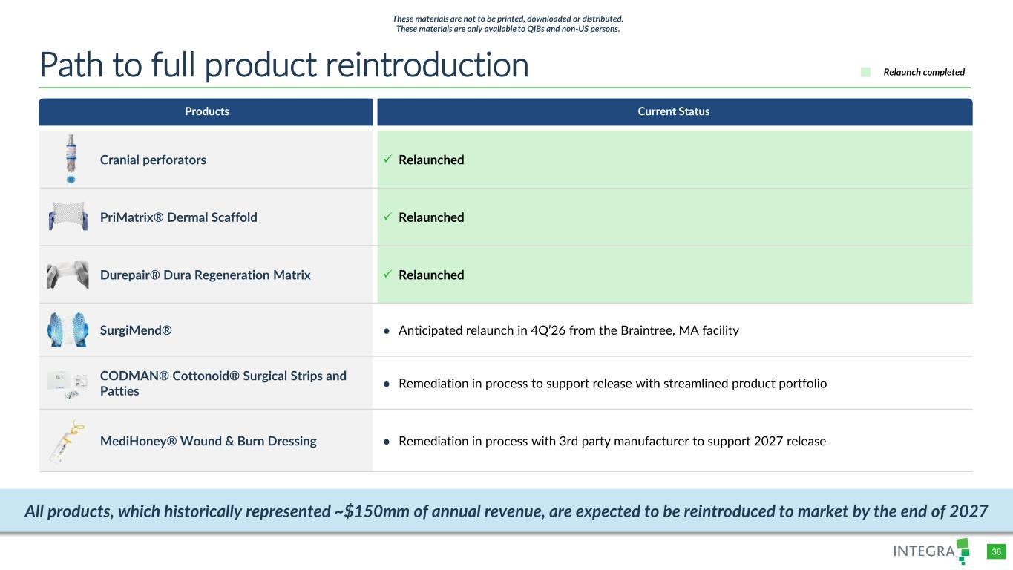
COLOR PALETTE Text 31 73 125 Title bar/Bullets 31 59 83 ACCENTS 1 31 59 83 140 179 212 2 30 105 142 143 202 231 3 47 177 52 165 231 167 4 54 132 156 166 210 224 5 140 181 202 209 225 234 6 191 191 191 229 229 229 Hyperlink 31 59 83 140 179 212 Followed Hyperlink 30 105 142 143 202 231 Lines 31 73 125 Highlights 31 59 83 TABLE 36 Products Current Status Cranial perforators ✓ Relaunched PriMatrix® Dermal Scaffold ✓ Relaunched Durepair® Dura Regeneration Matrix ✓ Relaunched SurgiMend® ● Anticipated relaunch in 4Q’26 from the Braintree, MA facility CODMAN® Cottonoid® Surgical Strips and Patties ● Remediation in process to support release with streamlined product portfolio MediHoney® Wound & Burn Dressing ● Remediation in process with 3rd party manufacturer to support 2027 release Path to full product reintroduction Relaunch completed These materials are not to be printed, downloaded or distributed. These materials are only available to QIBs and non-US persons. All products, which historically represented ~$150mm of annual revenue, are expected to be reintroduced to market by the end of 2027

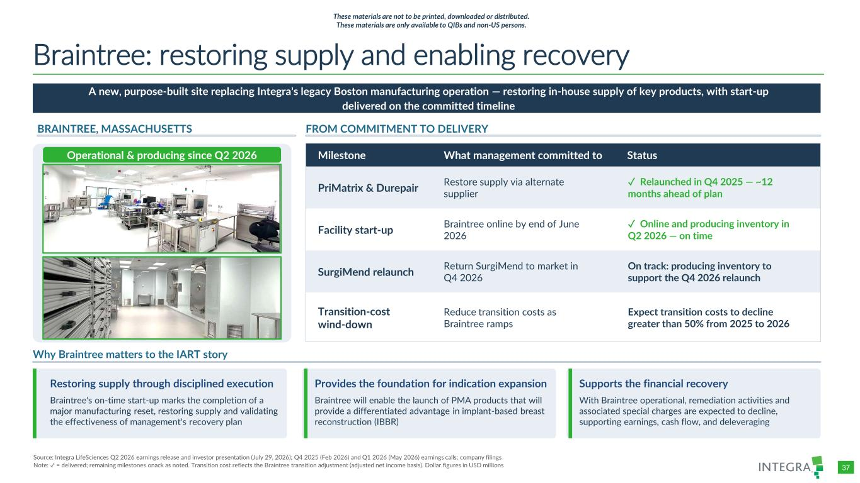
COLOR PALETTE Text 31 73 125 Title bar/Bullets 31 59 83 ACCENTS 1 31 59 83 140 179 212 2 30 105 142 143 202 231 3 47 177 52 165 231 167 4 54 132 156 166 210 224 5 140 181 202 209 225 234 6 191 191 191 229 229 229 Hyperlink 31 59 83 140 179 212 Followed Hyperlink 30 105 142 143 202 231 Lines 31 73 125 Highlights 31 59 83 TABLE 37 Braintree: restoring supply and enabling recovery A new, purpose-built site replacing Integra's legacy Boston manufacturing operation — restoring in-house supply of key products, with start-up delivered on the committed timeline BRAINTREE, MASSACHUSETTS FROM COMMITMENT TO DELIVERY Milestone What management committed to Status Facility start-up Braintree online by end of June 2026 ✓ Online and producing inventory in Q2 2026 — on time SurgiMend relaunch Return SurgiMend to market in Q4 2026 On track: producing inventory to support the Q4 2026 relaunch PriMatrix & Durepair Restore supply via alternate supplier ✓ Relaunched in Q4 2025 — ~12 months ahead of plan Transition-cost wind-down Reduce transition costs as Braintree ramps Expect transition costs to decline greater than 50% from 2025 to 2026 Why Braintree matters to the IART story Restoring supply through disciplined execution Braintree's on-time start-up marks the completion of a major manufacturing reset, restoring supply and validating the effectiveness of management's recovery plan Provides the foundation for indication expansion Braintree will enable the launch of PMA products that will provide a differentiated advantage in implant-based breast reconstruction (IBBR) Supports the financial recovery With Braintree operational, remediation activities and associated special charges are expected to decline, supporting earnings, cash flow, and deleveraging Source: Integra LifeSciences Q2 2026 earnings release and investor presentation (July 29, 2026); Q4 2025 (Feb 2026) and Q1 2026 (May 2026) earnings calls; company filings Note: ✓ = delivered; remaining milestones onack as noted. Transition cost reflects the Braintree transition adjustment (adjusted net income basis). Dollar figures in USD millions Operational & producing since Q2 2026 Management has delivered the recovery milestones it committed to — a constructive signal for the commitments still ahead. These materials are not to be printed, downloaded or distributed. These materials are only available to QIBs and non-US persons.

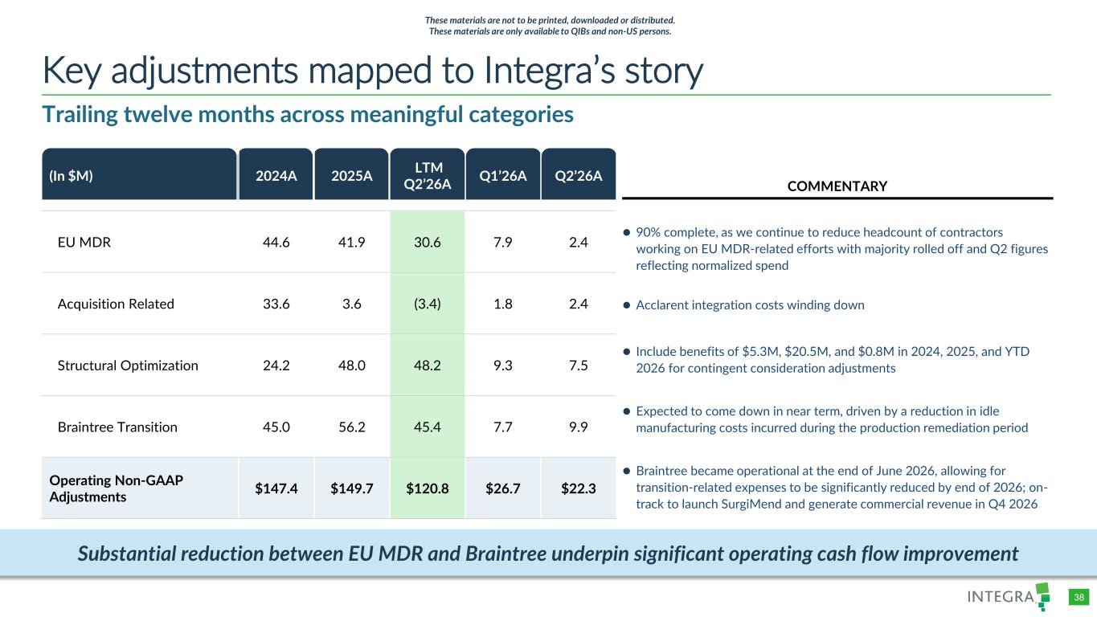
COLOR PALETTE Text 31 73 125 Title bar/Bullets 31 59 83 ACCENTS 1 31 59 83 140 179 212 2 30 105 142 143 202 231 3 47 177 52 165 231 167 4 54 132 156 166 210 224 5 140 181 202 209 225 234 6 191 191 191 229 229 229 Hyperlink 31 59 83 140 179 212 Followed Hyperlink 30 105 142 143 202 231 Lines 31 73 125 Highlights 31 59 83 TABLE 38 Trailing twelve months across meaningful categories Key adjustments mapped to Integra’s story (In $M) 2024A 2025A LTM Q2’26A Q1’26A Q2’26A EU MDR 44.6 41.9 30.6 7.9 2.4 Acquisition Related 33.6 3.6 (3.4) 1.8 2.4 Structural Optimization 24.2 48.0 48.2 9.3 7.5 Braintree Transition 45.0 56.2 45.4 7.7 9.9 Operating Non-GAAP Adjustments $147.4 $149.7 $120.8 $26.7 $22.3 Substantial reduction between EU MDR and Braintree underpin significant operating cash flow improvement COMMENTARY These materials are not to be printed, downloaded or distributed. These materials are only available to QIBs and non-US persons. ⚫ 90% complete, as we continue to reduce headcount of contractors working on EU MDR-related efforts with majority rolled off and Q2 figures reflecting normalized spend ⚫ Acclarent integration costs winding down ⚫ Expected to come down in near term, driven by a reduction in idle manufacturing costs incurred during the production remediation period ⚫ Braintree became operational at the end of June 2026, allowing for transition-related expenses to be significantly reduced by end of 2026; on- track to launch SurgiMend and generate commercial revenue in Q4 2026 ⚫ Include benefits of $5.3M, $20.5M, and $0.8M in 2024, 2025, and YTD 2026 for contingent consideration adjustments


/Admin/ADVANCED GRAPHICS FILES/Cover and Template/2026/2026_03/4714660-001_Integra_Chelsea Lin_Dividers Investment highlights 06 These materials are not to be printed, downloaded or distributed. These materials are only available to QIBs and non-US persons.

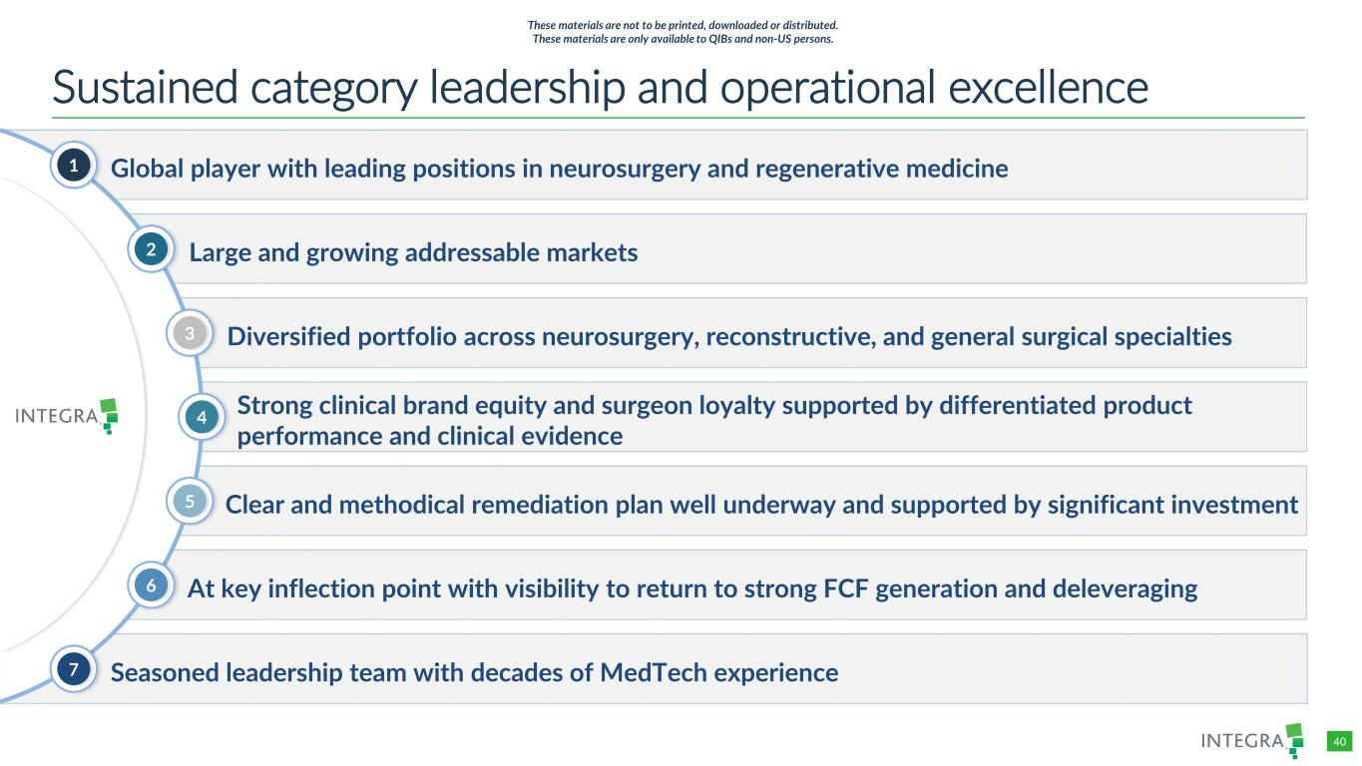
COLOR PALETTE Text 31 73 125 Title bar/Bullets 31 59 83 ACCENTS 1 31 59 83 140 179 212 2 30 105 142 143 202 231 3 47 177 52 165 231 167 4 54 132 156 166 210 224 5 140 181 202 209 225 234 6 191 191 191 229 229 229 Hyperlink 31 59 83 140 179 212 Followed Hyperlink 30 105 142 143 202 231 Lines 31 73 125 Highlights 31 59 83 TABLE 40 Strong clinical brand equity and surgeon loyalty supported by differentiated product performance and clinical evidence Sustained category leadership and operational excellence Global player with leading positions in neurosurgery and regenerative medicine Seasoned leadership team with decades of MedTech experience Large and growing addressable markets Diversified portfolio across neurosurgery, reconstructive, and general surgical specialties Clear and methodical remediation plan well underway and supported by significant investment At key inflection point with visibility to return to strong FCF generation and deleveraging 1 2 4 5 6 3 7 These materials are not to be printed, downloaded or distributed. These materials are only available to QIBs and non-US persons.

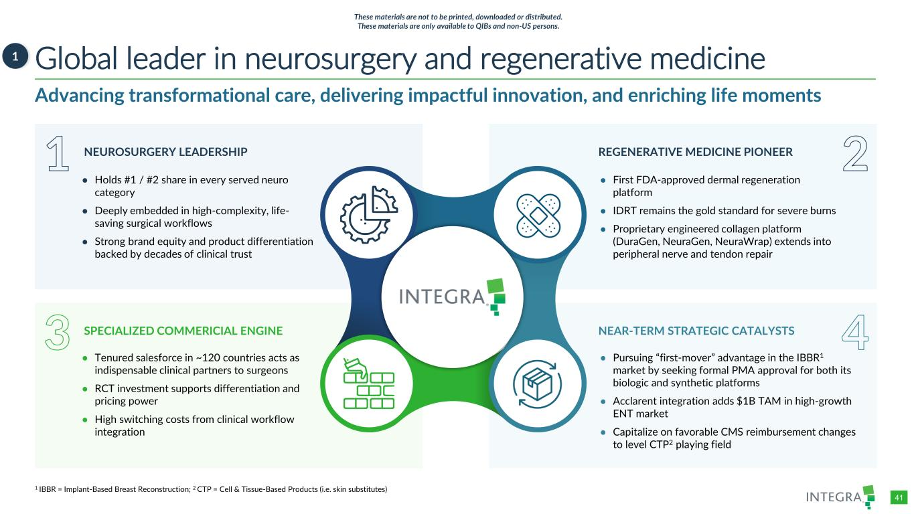
COLOR PALETTE Text 31 73 125 Title bar/Bullets 31 59 83 ACCENTS 1 31 59 83 140 179 212 2 30 105 142 143 202 231 3 47 177 52 165 231 167 4 54 132 156 166 210 224 5 140 181 202 209 225 234 6 191 191 191 229 229 229 Hyperlink 31 59 83 140 179 212 Followed Hyperlink 30 105 142 143 202 231 Lines 31 73 125 Highlights 31 59 83 TABLE 41 Global leader in neurosurgery and regenerative medicine1 Advancing transformational care, delivering impactful innovation, and enriching life moments 1 2 3 4 NEUROSURGERY LEADERSHIP SPECIALIZED COMMERICIAL ENGINE REGENERATIVE MEDICINE PIONEER NEAR-TERM STRATEGIC CATALYSTS ● Holds #1 / #2 share in every served neuro category ● Deeply embedded in high-complexity, life- saving surgical workflows ● Strong brand equity and product differentiation backed by decades of clinical trust ● First FDA-approved dermal regeneration platform ● IDRT remains the gold standard for severe burns ● Proprietary engineered collagen platform (DuraGen, NeuraGen, NeuraWrap) extends into peripheral nerve and tendon repair ● Tenured salesforce in ~120 countries acts as indispensable clinical partners to surgeons ● RCT investment supports differentiation and pricing power ● High switching costs from clinical workflow integration ● Pursuing “first-mover” advantage in the IBBR1 market by seeking formal PMA approval for both its biologic and synthetic platforms ● Acclarent integration adds $1B TAM in high-growth ENT market ● Capitalize on favorable CMS reimbursement changes to level CTP2 playing field 1 IBBR = Implant-Based Breast Reconstruction; 2 CTP = Cell & Tissue-Based Products (i.e. skin substitutes) These materials are not to be printed, downloaded or distributed. These materials are only available to QIBs and non-US persons.

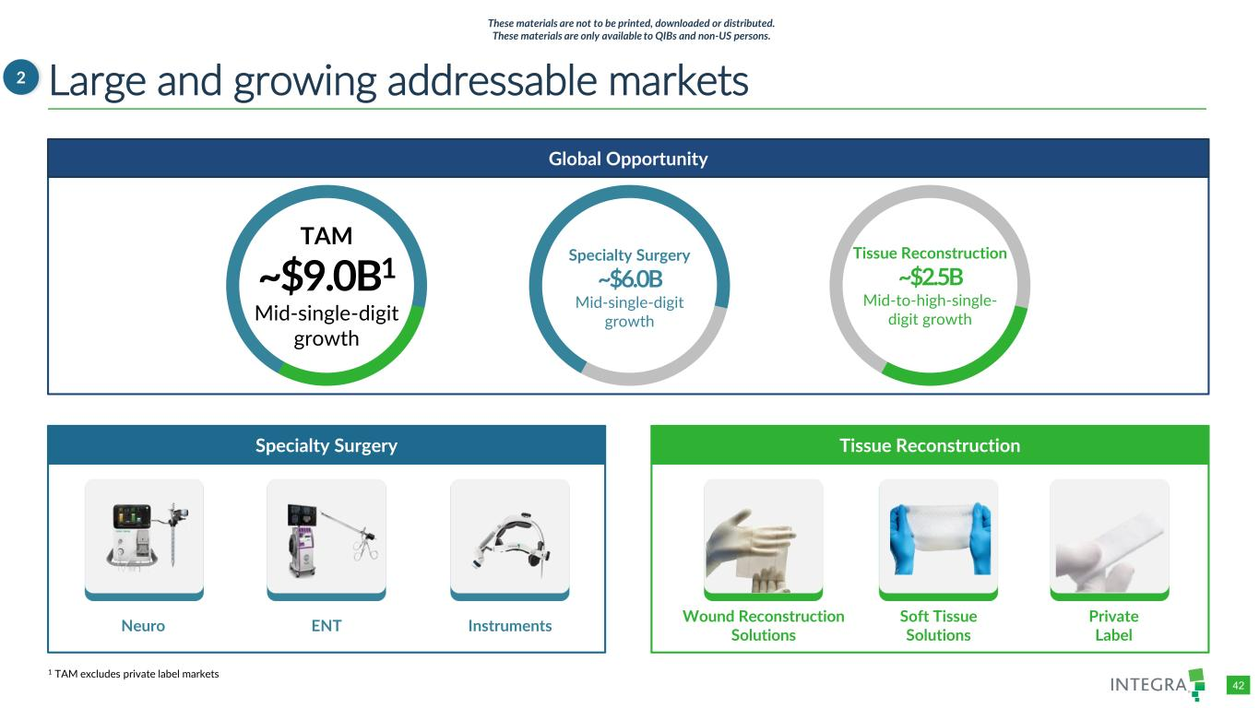
COLOR PALETTE Text 31 73 125 Title bar/Bullets 31 59 83 ACCENTS 1 31 59 83 140 179 212 2 30 105 142 143 202 231 3 47 177 52 165 231 167 4 54 132 156 166 210 224 5 140 181 202 209 225 234 6 191 191 191 229 229 229 Hyperlink 31 59 83 140 179 212 Followed Hyperlink 30 105 142 143 202 231 Lines 31 73 125 Highlights 31 59 83 TABLE 42 Global Opportunity Specialty Surgery Tissue Reconstruction Large and growing addressable markets2 Private LabelNeuro ENT Instruments Wound Reconstruction Solutions Specialty Surgery ~$6.0B Mid-single-digit growth Tissue Reconstruction ~$2.5B Mid-to-high-single- digit growth TAM ~$9.0B1 Mid-single-digit growth Soft Tissue Solutions These materials are not to be printed, downloaded or distributed. These materials are only available to QIBs and non-US persons. 1 TAM excludes private label markets

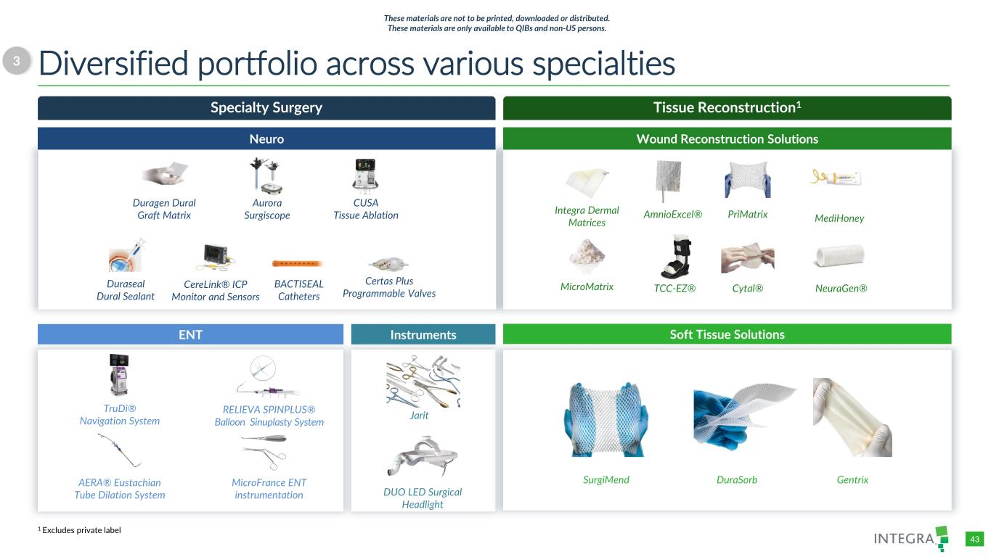
COLOR PALETTE Text 31 73 125 Title bar/Bullets 31 59 83 ACCENTS 1 31 59 83 140 179 212 2 30 105 142 143 202 231 3 47 177 52 165 231 167 4 54 132 156 166 210 224 5 140 181 202 209 225 234 6 191 191 191 229 229 229 Hyperlink 31 59 83 140 179 212 Followed Hyperlink 30 105 142 143 202 231 Lines 31 73 125 Highlights 31 59 83 TABLE 43 Diversified portfolio across various specialties3 Tissue Reconstruction1 Wound Reconstruction Solutions Specialty Surgery Neuro ENT Instruments Soft Tissue Solutions TruDi® Navigation System RELIEVA SPINPLUS® Balloon Sinuplasty System AERA® Eustachian Tube Dilation System MicroFrance ENT instrumentation Integra Dermal Matrices AmnioExcel® PriMatrix MicroMatrix TCC-EZ® Cytal® NeuraGen® Duragen Dural Graft Matrix Aurora Surgiscope CUSA Tissue Ablation Duraseal Dural Sealant CereLink® ICP Monitor and Sensors Certas Plus Programmable Valves BACTISEAL Catheters Jarit DUO LED Surgical Headlight SurgiMend DuraSorb Gentrix MediHoney 1 Excludes private label These materials are not to be printed, downloaded or distributed. These materials are only available to QIBs and non-US persons.

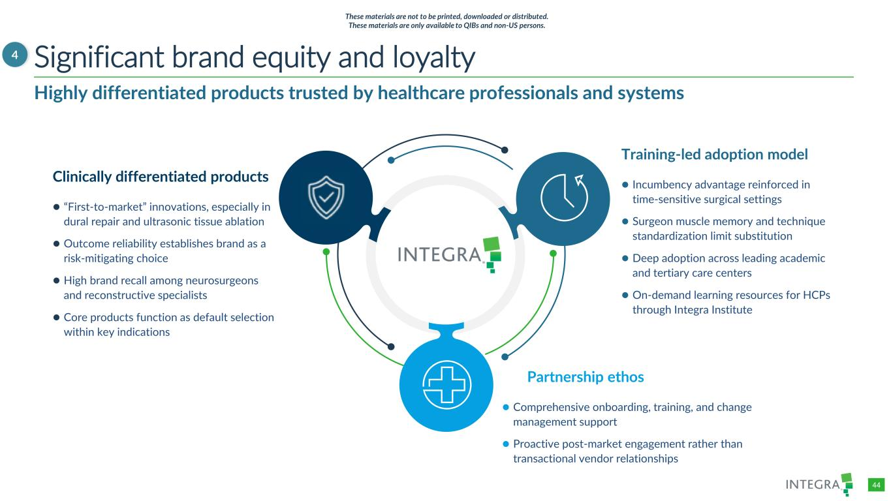
COLOR PALETTE Text 31 73 125 Title bar/Bullets 31 59 83 ACCENTS 1 31 59 83 140 179 212 2 30 105 142 143 202 231 3 47 177 52 165 231 167 4 54 132 156 166 210 224 5 140 181 202 209 225 234 6 191 191 191 229 229 229 Hyperlink 31 59 83 140 179 212 Followed Hyperlink 30 105 142 143 202 231 Lines 31 73 125 Highlights 31 59 83 TABLE 44 Significant brand equity and loyalty4 Highly differentiated products trusted by healthcare professionals and systems Partnership ethos ⚫ Comprehensive onboarding, training, and change management support ⚫ Proactive post-market engagement rather than transactional vendor relationships Clinically differentiated products ⚫ “First-to-market” innovations, especially in dural repair and ultrasonic tissue ablation ⚫ Outcome reliability establishes brand as a risk-mitigating choice ⚫ High brand recall among neurosurgeons and reconstructive specialists ⚫ Core products function as default selection within key indications Training-led adoption model ⚫ Incumbency advantage reinforced in time-sensitive surgical settings ⚫ Surgeon muscle memory and technique standardization limit substitution ⚫ Deep adoption across leading academic and tertiary care centers ⚫ On-demand learning resources for HCPs through Integra Institute These materials are not to be printed, downloaded or distributed. These materials are only available to QIBs and non-US persons.

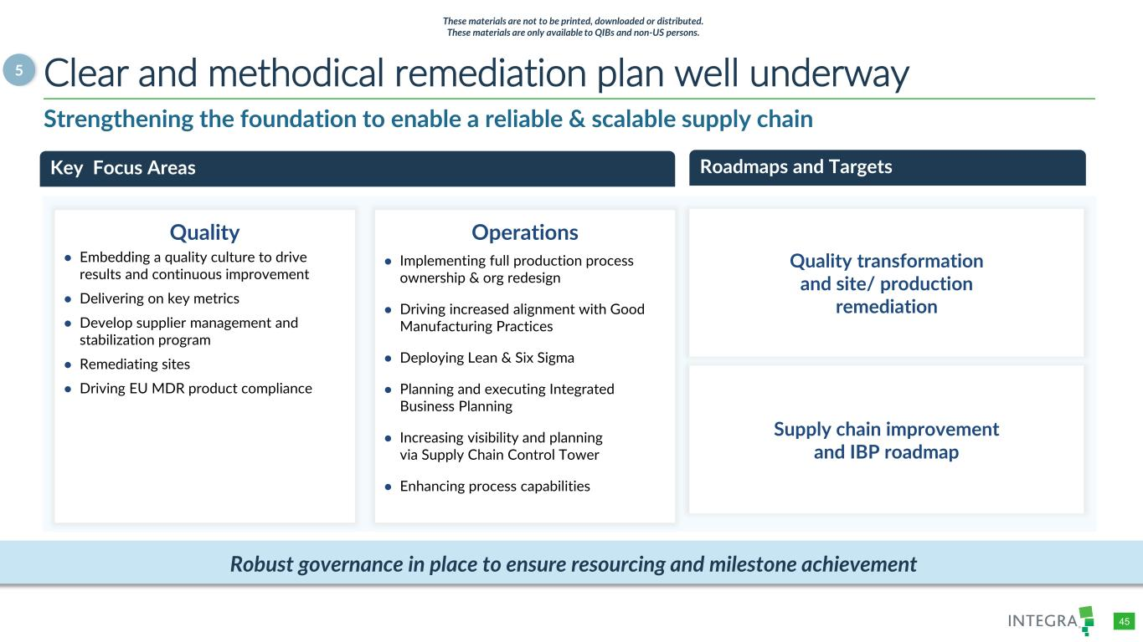
COLOR PALETTE Text 31 73 125 Title bar/Bullets 31 59 83 ACCENTS 1 31 59 83 140 179 212 2 30 105 142 143 202 231 3 47 177 52 165 231 167 4 54 132 156 166 210 224 5 140 181 202 209 225 234 6 191 191 191 229 229 229 Hyperlink 31 59 83 140 179 212 Followed Hyperlink 30 105 142 143 202 231 Lines 31 73 125 Highlights 31 59 83 TABLE 45 Clear and methodical remediation plan well underway5 Roadmaps and Targets Supply chain improvement and IBP roadmap Strengthening the foundation to enable a reliable & scalable supply chain Quality transformation and site/ production remediation Key Focus Areas Quality ● Embedding a quality culture to drive results and continuous improvement ● Delivering on key metrics ● Develop supplier management and stabilization program ● Remediating sites ● Driving EU MDR product compliance Operations ● Implementing full production process ownership & org redesign ● Driving increased alignment with Good Manufacturing Practices ● Deploying Lean & Six Sigma ● Planning and executing Integrated Business Planning ● Increasing visibility and planning via Supply Chain Control Tower ● Enhancing process capabilities Robust governance in place to ensure resourcing and milestone achievement These materials are not to be printed, downloaded or distributed. These materials are only available to QIBs and non-US persons.

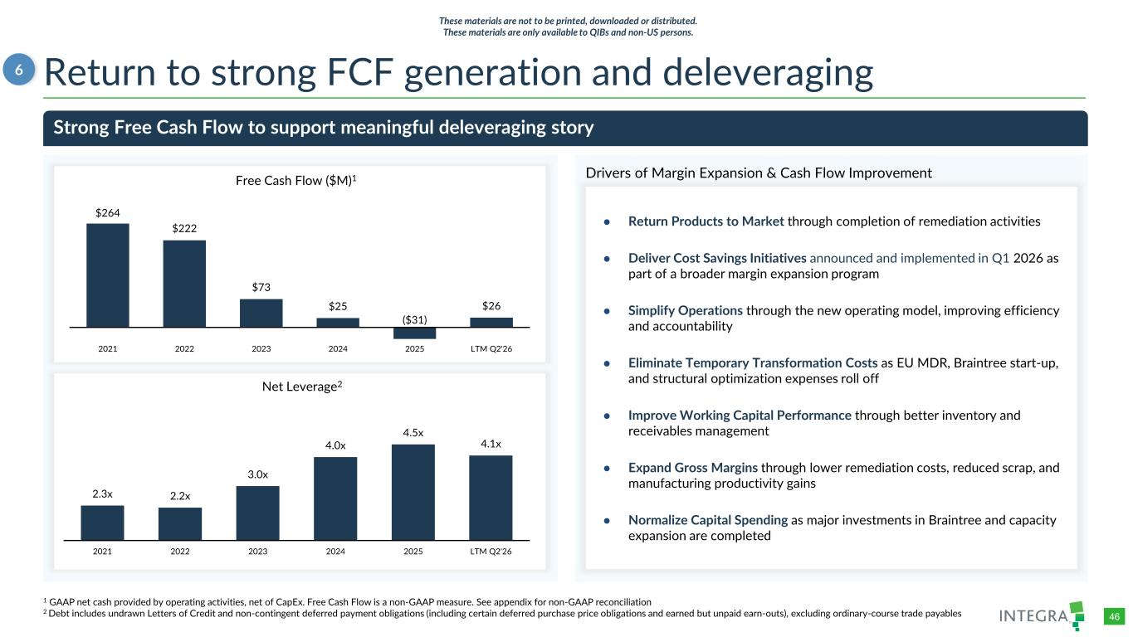
COLOR PALETTE Text 31 73 125 Title bar/Bullets 31 59 83 ACCENTS 1 31 59 83 140 179 212 2 30 105 142 143 202 231 3 47 177 52 165 231 167 4 54 132 156 166 210 224 5 140 181 202 209 225 234 6 191 191 191 229 229 229 Hyperlink 31 59 83 140 179 212 Followed Hyperlink 30 105 142 143 202 231 Lines 31 73 125 Highlights 31 59 83 TABLE 46 Return to strong FCF generation and deleveraging $264 $222 $73 $25 ($31) $26 2021 2022 2023 2024 2025 LTM Q2'26 Free Cash Flow ($M)1 Strong Free Cash Flow to support meaningful deleveraging story 2.3x 2.2x 3.0x 4.0x 4.5x 4.1x 2021 2022 2023 2024 2025 LTM Q2'26 Net Leverage2 6 1 GAAP net cash provided by operating activities, net of CapEx. Free Cash Flow is a non-GAAP measure. See appendix for non-GAAP reconciliation 2 Debt includes undrawn Letters of Credit and non-contingent deferred payment obligations (including certain deferred purchase price obligations and earned but unpaid earn-outs), excluding ordinary-course trade payables These materials are not to be printed, downloaded or distributed. These materials are only available to QIBs and non-US persons. ● Return Products to Market through completion of remediation activities ● Deliver Cost Savings Initiatives announced and implemented in Q1 2026 as part of a broader margin expansion program ● Simplify Operations through the new operating model, improving efficiency and accountability ● Eliminate Temporary Transformation Costs as EU MDR, Braintree start-up, and structural optimization expenses roll off ● Improve Working Capital Performance through better inventory and receivables management ● Expand Gross Margins through lower remediation costs, reduced scrap, and manufacturing productivity gains ● Normalize Capital Spending as major investments in Braintree and capacity expansion are completed Drivers of Margin Expansion & Cash Flow Improvement

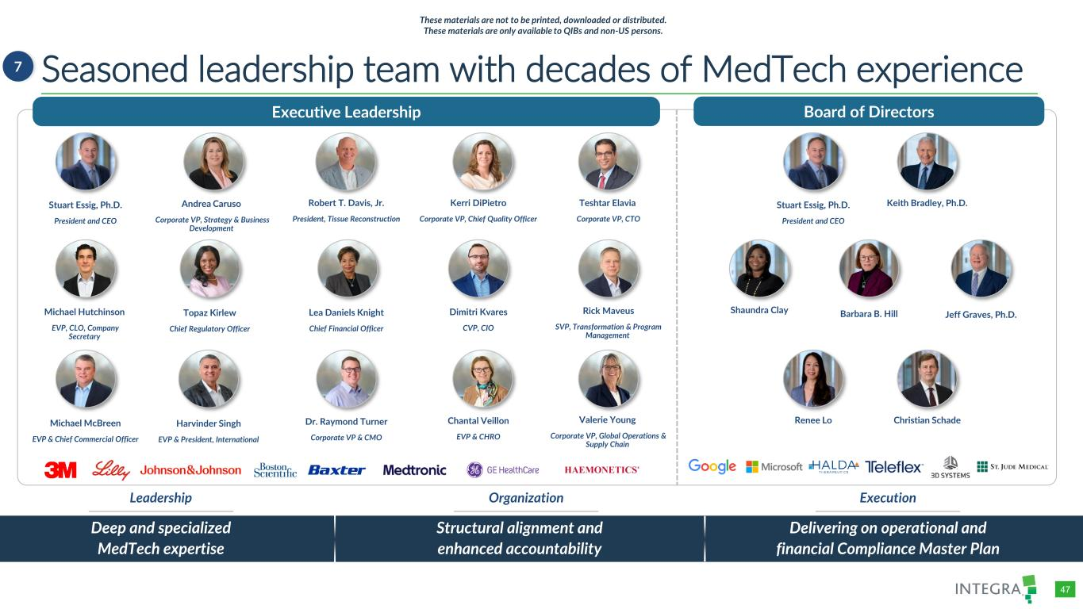
COLOR PALETTE Text 31 73 125 Title bar/Bullets 31 59 83 ACCENTS 1 31 59 83 140 179 212 2 30 105 142 143 202 231 3 47 177 52 165 231 167 4 54 132 156 166 210 224 5 140 181 202 209 225 234 6 191 191 191 229 229 229 Hyperlink 31 59 83 140 179 212 Followed Hyperlink 30 105 142 143 202 231 Lines 31 73 125 Highlights 31 59 83 TABLE 47 Seasoned leadership team with decades of MedTech experience7 Leadership ExecutionExecutive Leadership Board of Direct rs Stuart Essig, Ph.D. President and CEO Andrea Caruso Corporate VP, Strategy & Business Development Dr. Raymond Turner Corporate VP & CMO Kerri DiPietro Corporate VP, Chief Quality Officer Robert T. Davis, Jr. President, Tissue Reconstruction Michael McBreen EVP & Chief Commercial Officer Dimitri Kvares CVP, CIO Topaz Kirlew Chief Regulatory Officer Keith Bradley, Ph.D. Shaundra Clay Barbara B. Hill Jeff Graves, Ph.D. Deep and specialized MedTech expertise Structural alignment and enhanced accountability Delivering on operational and financial Compliance Master Plan Leadership Organization Execution Teshtar Elavia Corporate VP, CTO Lea Daniels Knight Chief Financial Officer Chantal Veillon EVP & CHRO Michael Hutchinson EVP, CLO, Company Secretary Harvinder Singh EVP & President, International Rick Maveus SVP, Transformation & Program Management Valerie Young Corporate VP, Global Operations & Supply Chain Stuart Essig, Ph.D. President and CEO Renee Lo Christian Schade These materials are not to be printed, downloaded or distributed. These materials are only available to QIBs and non-US persons.


/Admin/ADVANCED GRAPHICS FILES/Cover and Template/2026/2026_03/4714660-001_Integra_Chelsea Lin_Dividers Financial summary 07 These materials are not to be printed, downloaded or distributed. These materials are only available to QIBs and non-US persons.

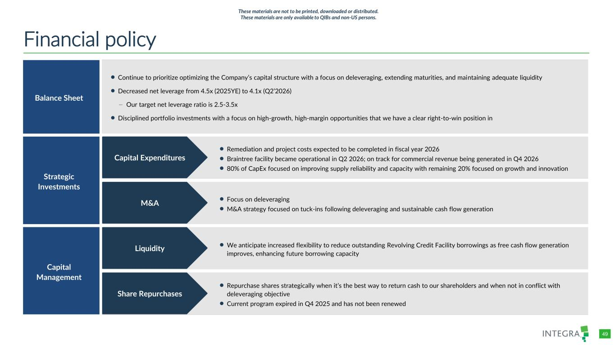
COLOR PALETTE Text 31 73 125 Title bar/Bullets 31 59 83 ACCENTS 1 31 59 83 140 179 212 2 30 105 142 143 202 231 3 47 177 52 165 231 167 4 54 132 156 166 210 224 5 140 181 202 209 225 234 6 191 191 191 229 229 229 Hyperlink 31 59 83 140 179 212 Followed Hyperlink 30 105 142 143 202 231 Lines 31 73 125 Highlights 31 59 83 TABLE 49 Financial policy Balance Sheet ⚫ Continue to prioritize optimizing the Company’s capital structure with a focus on deleveraging, extending maturities, and maintaining adequate liquidity ⚫ Decreased net leverage from 4.5x (2025YE) to 4.1x (Q2’2026) – Our target net leverage ratio is 2.5-3.5x ⚫ Disciplined portfolio investments with a focus on high-growth, high-margin opportunities that we have a clear right-to-win position in Strategic Investments ⚫ Remediation and project costs expected to be completed in fiscal year 2026 ⚫ Braintree facility became operational in Q2 2026; on track for commercial revenue being generated in Q4 2026 ⚫ 80% of CapEx focused on improving supply reliability and capacity with remaining 20% focused on growth and innovation ⚫ Focus on deleveraging ⚫ M&A strategy focused on tuck-ins following deleveraging and sustainable cash flow generation Capital Management ⚫ We anticipate increased flexibility to reduce outstanding Revolving Credit Facility borrowings as free cash flow generation improves, enhancing future borrowing capacity ⚫ Repurchase shares strategically when it’s the best way to return cash to our shareholders and when not in conflict with deleveraging objective ⚫ Current program expired in Q4 2025 and has not been renewed Capital Expenditures Liquidity M&A Share Repurchases These materials are not to be printed, downloaded or distributed. These materials are only available to QIBs and non-US persons.

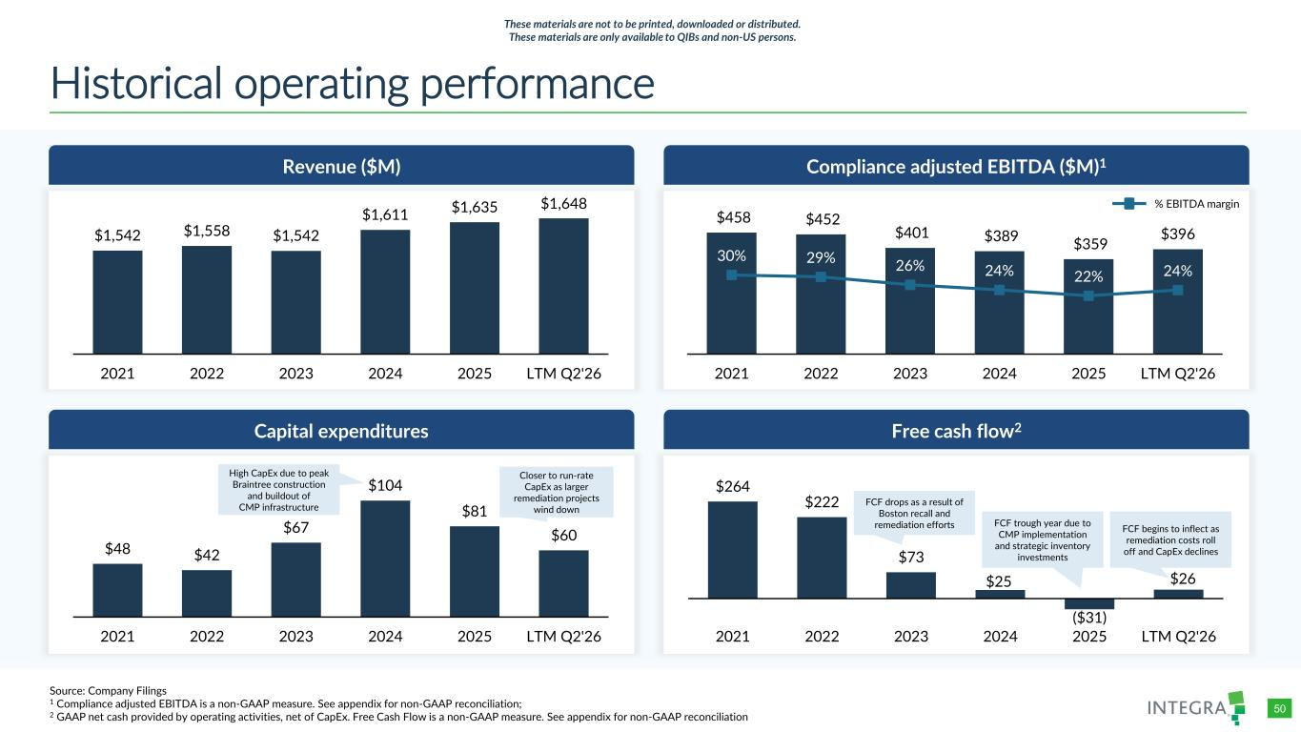
COLOR PALETTE Text 31 73 125 Title bar/Bullets 31 59 83 ACCENTS 1 31 59 83 140 179 212 2 30 105 142 143 202 231 3 47 177 52 165 231 167 4 54 132 156 166 210 224 5 140 181 202 209 225 234 6 191 191 191 229 229 229 Hyperlink 31 59 83 140 179 212 Followed Hyperlink 30 105 142 143 202 231 Lines 31 73 125 Highlights 31 59 83 TABLE 50 Historical operating performance Revenue ($M) Capital expenditures Compliance adjusted EBITDA ($M)1 Free cash flow2 $1,542 $1,558 $1,542 $1,611 $1,635 $1,648 2021 2022 2023 2024 2025 LTM Q2'26 $264 $222 $73 $25 ($31) $26 2021 2022 2023 2024 2025 LTM Q2'26 $458 $452 $401 $389 $359 $396 30% 29% 26% 24% 22% 24% 0% 5% 10% 15% 20% 25% 30% 35% 40% 45% 50% 2021 2022 2023 2024 2025 LTM Q2'26 $48 $42 $67 $104 $81 $60 2021 2022 2023 2024 2025 LTM Q2'26 FCF drops as a result of Boston recall and remediation efforts FCF trough year due to CMP implementation and strategic inventory investments High CapEx due to peak Braintree construction and buildout of CMP infrastructure Closer to run-rate CapEx as larger remediation projects wind down FCF begins to inflect as remediation costs roll off and CapEx declines Source: Company Filings 1 Compliance adjusted EBITDA is a non-GAAP measure. See appendix for non-GAAP reconciliation; 2 GAAP net cash provided by operating activities, net of CapEx. Free Cash Flow is a non-GAAP measure. See appendix for non-GAAP reconciliation % EBITDA margin These materials are not to be printed, downloaded or distributed. These materials are only available to QIBs and non-US persons.

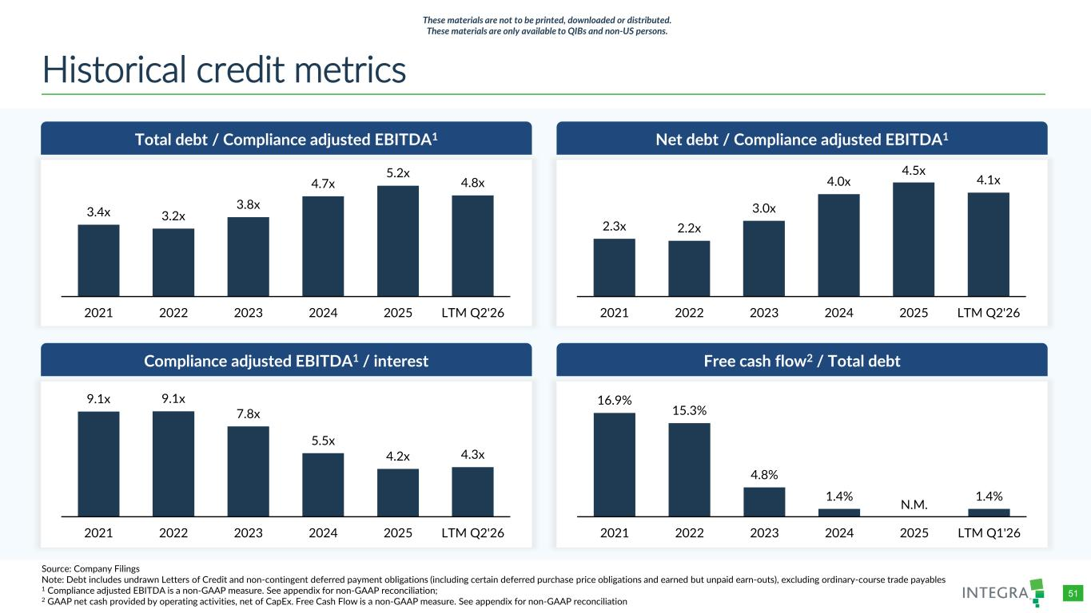
COLOR PALETTE Text 31 73 125 Title bar/Bullets 31 59 83 ACCENTS 1 31 59 83 140 179 212 2 30 105 142 143 202 231 3 47 177 52 165 231 167 4 54 132 156 166 210 224 5 140 181 202 209 225 234 6 191 191 191 229 229 229 Hyperlink 31 59 83 140 179 212 Followed Hyperlink 30 105 142 143 202 231 Lines 31 73 125 Highlights 31 59 83 TABLE 51 Historical credit metrics Total debt / Compliance adjusted EBITDA1 Compliance adjusted EBITDA1 / interest Net debt / Compliance adjusted EBITDA1 Free cash flow2 / Total debt 3.4x 3.2x 3.8x 4.7x 5.2x 4.8x 2021 2022 2023 2024 2025 LTM Q2'26 2.3x 2.2x 3.0x 4.0x 4.5x 4.1x 2021 2022 2023 2024 2025 LTM Q2'26 9.1x 9.1x 7.8x 5.5x 4.2x 4.3x 2021 2022 2023 2024 2025 LTM Q2'26 16.9% 15.3% 4.8% 1.4% N.M. 1.4% 2021 2022 2023 2024 2025 LTM Q1'26 Source: Company Filings Note: Debt includes undrawn Letters of Credit and non-contingent deferred payment obligations (including certain deferred purchase price obligations and earned but unpaid earn-outs), excluding ordinary-course trade payables 1 Compliance adjusted EBITDA is a non-GAAP measure. See appendix for non-GAAP reconciliation; 2 GAAP net cash provided by operating activities, net of CapEx. Free Cash Flow is a non-GAAP measure. See appendix for non-GAAP reconciliation These materials are not to be printed, downloaded or distributed. These materials are only available to QIBs and non-US persons.


/Admin/ADVANCED GRAPHICS FILES/Cover and Template/2026/2026_03/4714660-001_Integra_Chelsea Lin_Dividers Appendix 08 These materials are not to be printed, downloaded or distributed. These materials are only available to QIBs and non-US persons.

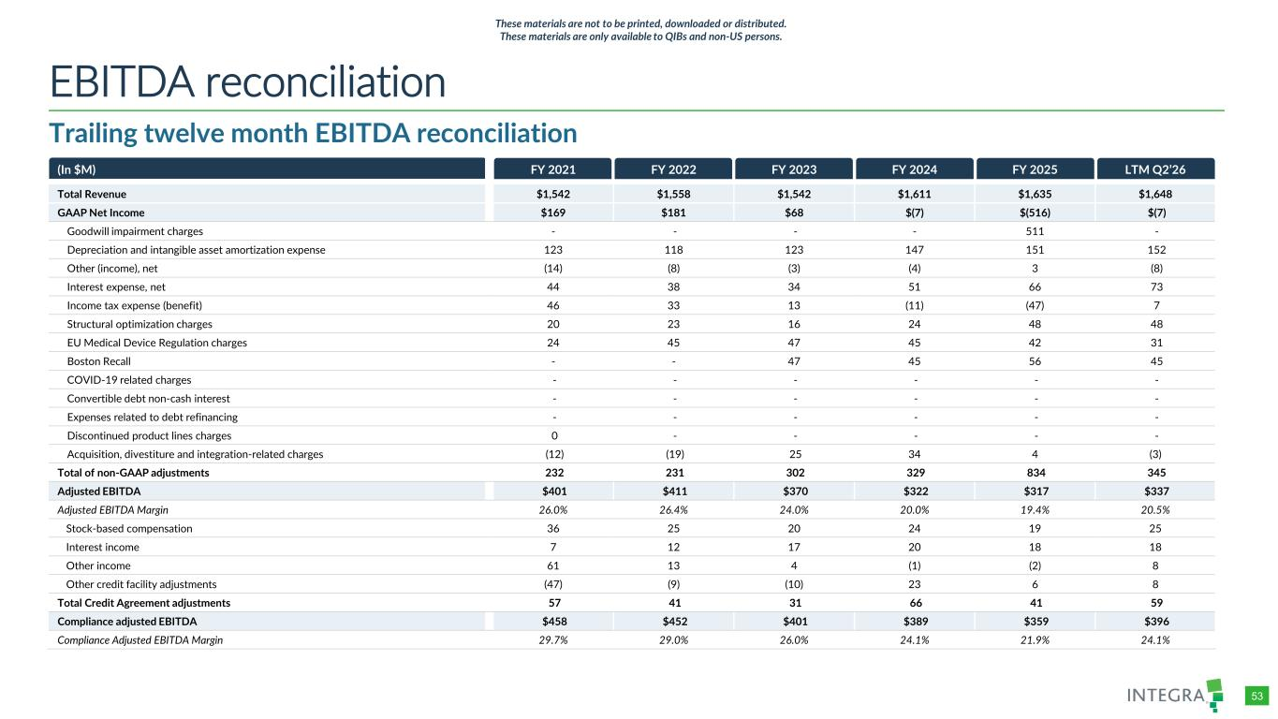
COLOR PALETTE Text 31 73 125 Title bar/Bullets 31 59 83 ACCENTS 1 31 59 83 140 179 212 2 30 105 142 143 202 231 3 47 177 52 165 231 167 4 54 132 156 166 210 224 5 140 181 202 209 225 234 6 191 191 191 229 229 229 Hyperlink 31 59 83 140 179 212 Followed Hyperlink 30 105 142 143 202 231 Lines 31 73 125 Highlights 31 59 83 TABLE 53 Trailing twelve month EBITDA reconciliation EBITDA reconciliation These materials are not to be printed, downloaded or distributed. These materials are only available to QIBs and non-US persons. (In $M) FY 2021 FY 2022 FY 2023 FY 2024 FY 2025 LTM Q2’26 Total Revenue $1,542 $1,558 $1,542 $1,611 $1,635 $1,648 GAAP Net Income $169 $181 $68 $(7) $(516) $(7) Goodwill impairment charges - - - - 511 - Depreciation and intangible asset amortization expense 123 118 123 147 151 152 Other (income), net (14) (8) (3) (4) 3 (8) Interest expense, net 44 38 34 51 66 73 Income tax expense (benefit) 46 33 13 (11) (47) 7 Structural optimization charges 20 23 16 24 48 48 EU Medical Device Regulation charges 24 45 47 45 42 31 Boston Recall - - 47 45 56 45 COVID-19 related charges - - - - - - Convertible debt non-cash interest - - - - - - Expenses related to debt refinancing - - - - - - Discontinued product lines charges 0 - - - - - Acquisition, divestiture and integration-related charges (12) (19) 25 34 4 (3) Total of non-GAAP adjustments 232 231 302 329 834 345 Adjusted EBITDA $401 $411 $370 $322 $317 $337 Adjusted EBITDA Margin 26.0% 26.4% 24.0% 20.0% 19.4% 20.5% Stock-based compensation 36 25 20 24 19 25 Interest income 7 12 17 20 18 18 Other income 61 13 4 (1) (2) 8 Other credit facility adjustments (47) (9) (10) 23 6 8 Total Credit Agreement adjustments 57 41 31 66 41 59 Compliance adjusted EBITDA $458 $452 $401 $389 $359 $396 Compliance Adjusted EBITDA Margin 29.7% 29.0% 26.0% 24.1% 21.9% 24.1%

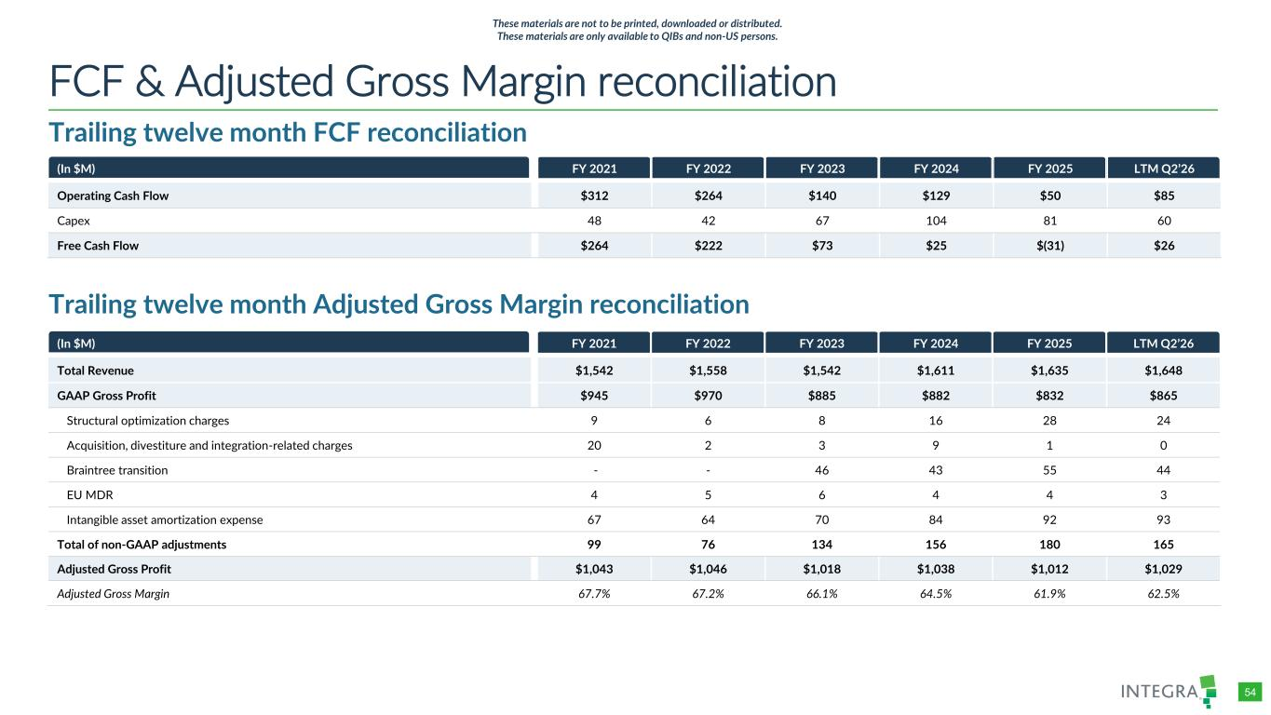
COLOR PALETTE Text 31 73 125 Title bar/Bullets 31 59 83 ACCENTS 1 31 59 83 140 179 212 2 30 105 142 143 202 231 3 47 177 52 165 231 167 4 54 132 156 166 210 224 5 140 181 202 209 225 234 6 191 191 191 229 229 229 Hyperlink 31 59 83 140 179 212 Followed Hyperlink 30 105 142 143 202 231 Lines 31 73 125 Highlights 31 59 83 TABLE 54 Trailing twelve month FCF reconciliation FCF & Adjusted Gross Margin reconciliation Trailing twelve month Adjusted Gross Margin reconciliation (In $M) FY 2021 FY 2022 FY 2023 FY 2024 FY 2025 LTM Q2’26 Operating Cash Flow $312 $264 $140 $129 $50 $85 Capex 48 42 67 104 81 60 Free Cash Flow $264 $222 $73 $25 $(31) $26 (In $M) FY 2021 FY 2022 FY 2023 FY 2024 FY 2025 LTM Q2’26 Total Revenue $1,542 $1,558 $1,542 $1,611 $1,635 $1,648 GAAP Gross Profit $945 $970 $885 $882 $832 $865 Structural optimization charges 9 6 8 16 28 24 Acquisition, divestiture and integration-related charges 20 2 3 9 1 0 Braintree transition - - 46 43 55 44 EU MDR 4 5 6 4 4 3 Intangible asset amortization expense 67 64 70 84 92 93 Total of non-GAAP adjustments 99 76 134 156 180 165 Adjusted Gross Profit $1,043 $1,046 $1,018 $1,038 $1,012 $1,029 Adjusted Gross Margin 67.7% 67.2% 66.1% 64.5% 61.9% 62.5% These materials are not to be printed, downloaded or distributed. These materials are only available to QIBs and non-US persons.

